Ishaan Jain (2K18/SE/067) Dheeraj Rukwal (2K18/SE/055)

**Project File- OOSE**

**Topic -- Air Ticket Reservation System**



**Submitted By ::**  **Submitted To::**

Ishaan Jain (2K18/SE/067) Dr Ruchika Malhotra

Dheeraj Rukwal(2K18/SE/055) Associate Professor

Dept. of Computer

Science and Engineering

Ishaan Jain (2K18/SE/067) Dheeraj Rukwal (2K18/SE/055)

**PROBLEM STATEMENT**

**(AIR TICKET RESERVATION SYSTEM)**

The most common mode of travelling nowadays is travelling by air.

The Internet has grown over the past few years and it has provided many functionalities to the airlines and to the users as well.

**But there are many problems in the current system and these are as::**

* Inability of passengers to select seat(s) for their chosen flight(s) from the existing reservation system
* The system does not give any notification to the user about the delay in the flights.
* No option for the passengers building their boarding pass in the existing system
* The existing system does not provide any information about the aircraft or pilot and his history .
* The existing system can be tricky to use and a bit confusing .
* Transaction gets cancelled .
* Luggage gets misplaced .

**The proposed solution to the problems are given in our system**

* The passengers have the option to choose their seat in case it is not available. They can choose their preferred seat from the available ones.
* The payment registration cancellation of the flights is done online.
* The system provides the users notification about the delay and cancellation in flights.
* The system provides the option for refund in case of cancellation of flight.
* All the information about the flight is provided
* The system is aimed to make it easy for the user to switch between various tasks

and menus .

* Provide information regarding the transaction status .
* Add luggage information during flight booking .

Ishaan Jain (2K18/SE/067) Dheeraj Rukwal (2K18/SE/055)

**INITIAL REQUIREMENT DOCUMENT**

**(AIR TICKET RESERVATION SYSTEM)**

|  |  |
| --- | --- |
| **Title of the Project :** | Air Ticket Reservation System |
| **Stakeholders Involved in Capturing Requirements :** | Administrator  Passengers  Departmental Staff |
| **Techniques Used For Requirement Capturing :** | Brainstorming |
| **Name of the persons along with designation :** | Dr Ruchika Malhotra  Ishaan Jain (2K18/SE/067)  Dheeraj Rukwal (2K18/SE/055) |
| **Date :** | 18 August , 2020 |
| **Version :** | 1.0 |
| **Consolidated List of Initial Requirement :**   1. We would design a system that would be functional on the administrator computer. And it would have the online website attached to it. 2. The system shall be able to generate the login id’s for the users/passengers,admin and for the departmental/airline staff. 3. The admin or the administrator is the one who controls the whole system and is the one of the main actors in the system. 4. The administrator looks into the data and the results associated with the system and adds it into the records and sends it to the higher personals. 5. Maintaining the airline data as in the flight details ,the arrival time ,departure time the delays and all. 6. Refund Transaction Amount on cancellation 7. Handling users information as in adding,updating,deleting passengers data. 8. Handling the departmental staff’s information. 9. Directing the departmental staff over various decisions. 10. Authenticate the users by their ids. 11. The user is the one for which all the work is done. The system is being automated for the better experience of the user. 12. The user logs into the system and then looks for the available flights and then he has the option to look for his preferred seats and then book accordingly. 13. The users can log into the system. 14. The users can book the tickets and choose their preferred seats accordingly. 15. The users can have access to their luggage while departing. 16. And the users have been provided functionality to cancel their ticket and have their money back in a short duration of time. 17. The departmental staff have their login ids and they can log in to the system and assist the users in various things. 18. They help the passengers in the reservation and all the ticket functionalities. 19. Announcing the delays in the flight. 20. Helping the users in the luggage. | |

Ishaan Jain (2K18/SE/067) Dheeraj Rukwal (2K18/SE/055)

**USE CASE DIAGRAM**

**(AIR TICKET RESERVATION SYSTEM)**

**Actors**

* Passenger
* Administrator
* Departmental Staff

**Use Cases**

* Login or Signup
* Booking a Ticket
* Payment
* View flight Details
* Maintain Flight Details
* Cancel Ticket
* Refund
* Add luggage Details
* Add Passport Details
* Maintain User Details
* Maintain Staff Details

Ishaan Jain (2K18/SE/067) Dheeraj Rukwal (2K18/SE/055)

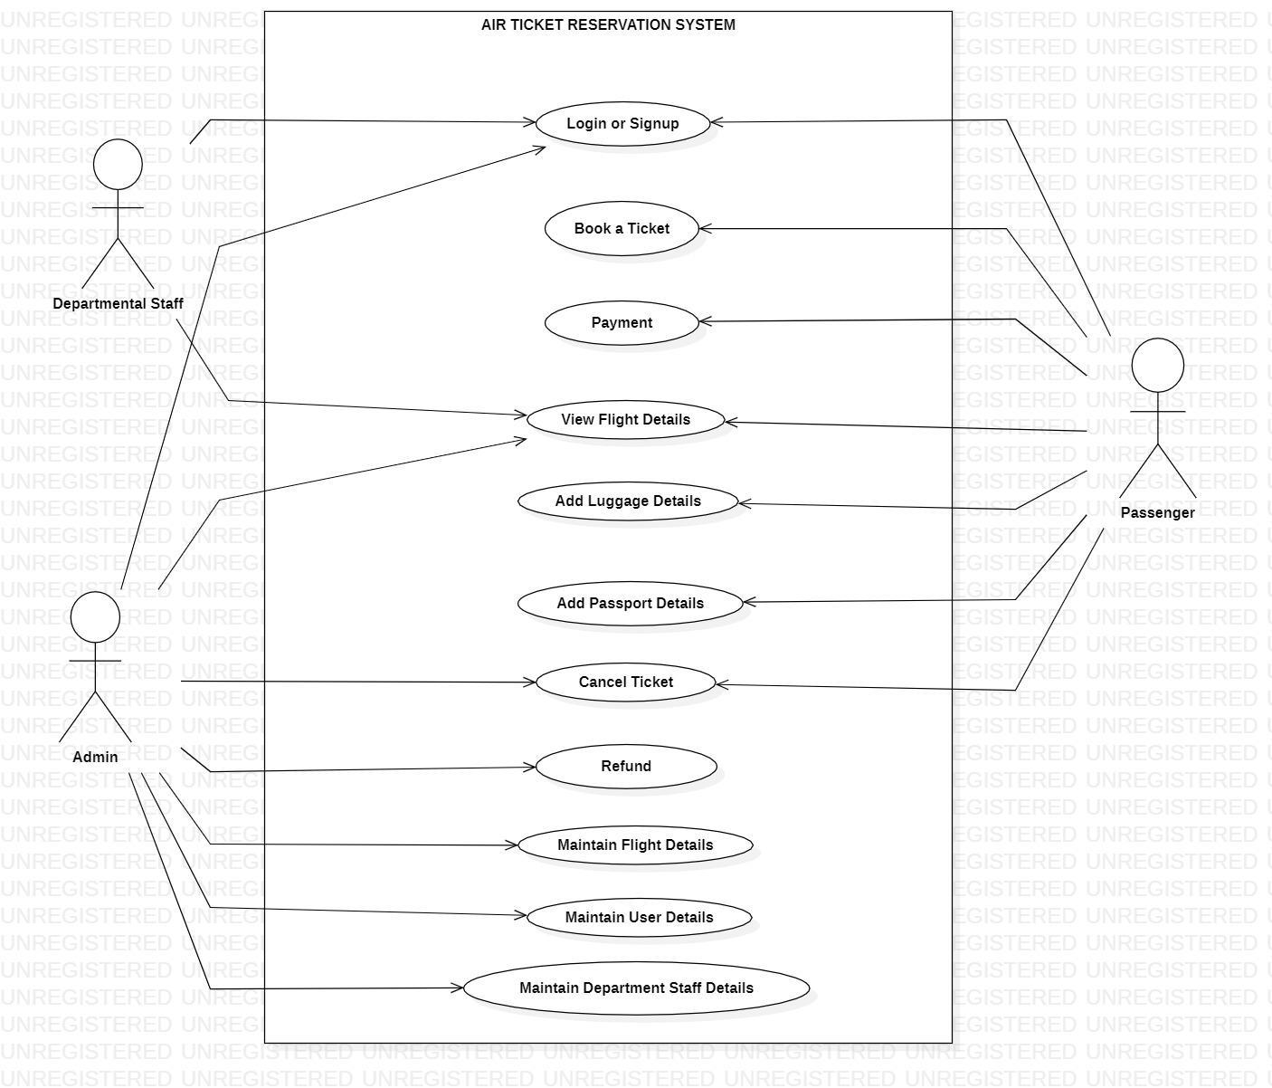

Ishaan Jain (2K18/SE/067) Dheeraj Rukwal (2K18/SE/055)

**Software Requirement Specification Document (SRS)**

**Version 1.0**

**September 19, 2020**

**Air Ticket Reservation System**

**Dheeraj Rukwal (2K18/SE/055)**

**Ishaan Jain(2K18/SE/067)**

**B.Tech. Software Engineering**

**5th Semester(SE-A1)**

Ishaan Jain (2K18/SE/067) Dheeraj Rukwal (2K18/SE/055)

Table of Contents

[1. INTRODUCTION 5](https://docs.google.com/document/d/15TD1g6nicpaCjknomn-ZtBp7rC9UlxQr/edit#heading=h.gjdgxs)

[1.1 PURPOSE: 6](https://docs.google.com/document/d/15TD1g6nicpaCjknomn-ZtBp7rC9UlxQr/edit#heading=h.30j0zll)

[1.2 SCOPE: 6](https://docs.google.com/document/d/15TD1g6nicpaCjknomn-ZtBp7rC9UlxQr/edit#heading=h.1fob9te)

[1.3 DEFINITIONS,ACRONYMS AND ABBREVIATIONS: 7](https://docs.google.com/document/d/15TD1g6nicpaCjknomn-ZtBp7rC9UlxQr/edit#heading=h.3znysh7)

[1.4 REFERENCES : 7](https://docs.google.com/document/d/15TD1g6nicpaCjknomn-ZtBp7rC9UlxQr/edit#heading=h.2et92p0)

[1.5 OVERVIEW : 7](https://docs.google.com/document/d/15TD1g6nicpaCjknomn-ZtBp7rC9UlxQr/edit#heading=h.tyjcwt)

[2. OVER ALL DESCRIPTION : 8](https://docs.google.com/document/d/15TD1g6nicpaCjknomn-ZtBp7rC9UlxQr/edit#heading=h.3dy6vkm)

[2.1 PRODUCT PERSPECTIVE: 9](https://docs.google.com/document/d/15TD1g6nicpaCjknomn-ZtBp7rC9UlxQr/edit#heading=h.1t3h5sf)

[2.1.1 USER INTERFACES: 9](https://docs.google.com/document/d/15TD1g6nicpaCjknomn-ZtBp7rC9UlxQr/edit#heading=h.4d34og8)

[2.1.2 HARDWARE INTERFACES: 10](https://docs.google.com/document/d/15TD1g6nicpaCjknomn-ZtBp7rC9UlxQr/edit#heading=h.2s8eyo1)

[2.1.3 SOFTWARE INTERFACES: 10](https://docs.google.com/document/d/15TD1g6nicpaCjknomn-ZtBp7rC9UlxQr/edit#heading=h.17dp8vu)

[2.1.4 COMMUNICATION INTERFACES: 10](https://docs.google.com/document/d/15TD1g6nicpaCjknomn-ZtBp7rC9UlxQr/edit#heading=h.3rdcrjn)

[2.1.5 MEMORY CONSTRAINT: 10](https://docs.google.com/document/d/15TD1g6nicpaCjknomn-ZtBp7rC9UlxQr/edit#heading=h.26in1rg)

[2.1.6 SITE ADAPTATION REQUIREMENT: 10](https://docs.google.com/document/d/15TD1g6nicpaCjknomn-ZtBp7rC9UlxQr/edit#heading=h.lnxbz9)

[2.2 PRODUCT FUNCTIONS: 10](https://docs.google.com/document/d/15TD1g6nicpaCjknomn-ZtBp7rC9UlxQr/edit#heading=h.35nkun2)

[2.3 USER CHARACTERISTICS : 11](https://docs.google.com/document/d/15TD1g6nicpaCjknomn-ZtBp7rC9UlxQr/edit#heading=h.1ksv4uv)

[2.3.1 FOR ADMIN: 11](https://docs.google.com/document/d/15TD1g6nicpaCjknomn-ZtBp7rC9UlxQr/edit#heading=h.44sinio)

[2.3.2 FOR STAFF: 12](https://docs.google.com/document/d/15TD1g6nicpaCjknomn-ZtBp7rC9UlxQr/edit#heading=h.2jxsxqh)

[2.3.3 FOR PASSENGERS : 12](https://docs.google.com/document/d/15TD1g6nicpaCjknomn-ZtBp7rC9UlxQr/edit#heading=h.z337ya)

[2.4 DESIGN AND IMPLEMENTATION CONSTRAINTS : 12](https://docs.google.com/document/d/15TD1g6nicpaCjknomn-ZtBp7rC9UlxQr/edit#heading=h.3j2qqm3)

[2.5 ASSUMPTIONS AND DEPENDENCIES: 12](https://docs.google.com/document/d/15TD1g6nicpaCjknomn-ZtBp7rC9UlxQr/edit#heading=h.1y810tw)

[2.6 APPORTIONING OF REQUIREMENTS: 13](https://docs.google.com/document/d/15TD1g6nicpaCjknomn-ZtBp7rC9UlxQr/edit#heading=h.4i7ojhp)

Ishaan Jain (2K18/SE/067) Dheeraj Rukwal (2K18/SE/055)

[3. SPECIFIC REQUIREMENTS 13](https://docs.google.com/document/d/15TD1g6nicpaCjknomn-ZtBp7rC9UlxQr/edit#heading=h.2xcytpi)

[3.1 EXTERNAL INTERFACE REQUIREMENTS 13](https://docs.google.com/document/d/15TD1g6nicpaCjknomn-ZtBp7rC9UlxQr/edit#heading=h.1ci93xb)

[3.1.1 USER INTERFACES 13](https://docs.google.com/document/d/15TD1g6nicpaCjknomn-ZtBp7rC9UlxQr/edit#heading=h.3whwml4)

[1. HOME 13](https://docs.google.com/document/d/15TD1g6nicpaCjknomn-ZtBp7rC9UlxQr/edit#heading=h.2bn6wsx)

[2. LOGIN INTERFACE : 15](https://docs.google.com/document/d/15TD1g6nicpaCjknomn-ZtBp7rC9UlxQr/edit#heading=h.qsh70q)

[3. REGISTER INTERFACE 16](https://docs.google.com/document/d/15TD1g6nicpaCjknomn-ZtBp7rC9UlxQr/edit#heading=h.3as4poj)

[4. MY PROFILE 18](https://docs.google.com/document/d/15TD1g6nicpaCjknomn-ZtBp7rC9UlxQr/edit#heading=h.1pxezwc)

[4. BOOK TICKET INTERFACE 18](https://docs.google.com/document/d/15TD1g6nicpaCjknomn-ZtBp7rC9UlxQr/edit#heading=h.49x2ik5)

[5. VIEW TICKET INTERFACE 19](https://docs.google.com/document/d/15TD1g6nicpaCjknomn-ZtBp7rC9UlxQr/edit#heading=h.2p2csry)

[6. PAYMENT INTERFACE 20](https://docs.google.com/document/d/15TD1g6nicpaCjknomn-ZtBp7rC9UlxQr/edit#heading=h.147n2zr)

[3.1.2 HARDWARE INTERFACES: 23](https://docs.google.com/document/d/15TD1g6nicpaCjknomn-ZtBp7rC9UlxQr/edit#heading=h.3o7alnk)

[3.1.3 SOFTWARE INTERFACES : 23](https://docs.google.com/document/d/15TD1g6nicpaCjknomn-ZtBp7rC9UlxQr/edit#heading=h.23ckvvd)

[3.1.4 COMMUNICATION INTERFACES : 23](https://docs.google.com/document/d/15TD1g6nicpaCjknomn-ZtBp7rC9UlxQr/edit#heading=h.ihv636)

[3.2 FUNCTIONAL REQUIREMENTS 24](https://docs.google.com/document/d/15TD1g6nicpaCjknomn-ZtBp7rC9UlxQr/edit#heading=h.32hioqz)

[3.2.1 LOGIN OR SIGN-UP USE CASE 24](https://docs.google.com/document/d/15TD1g6nicpaCjknomn-ZtBp7rC9UlxQr/edit#heading=h.1hmsyys)

[3.2.2 MAINTAIN FLIGHT DETAILS USE CASE 25](https://docs.google.com/document/d/15TD1g6nicpaCjknomn-ZtBp7rC9UlxQr/edit#heading=h.41mghml)

[3.2.3 MAINTAIN PASSENGER DETAILS USE CASE 26](https://docs.google.com/document/d/15TD1g6nicpaCjknomn-ZtBp7rC9UlxQr/edit#heading=h.2grqrue)

[3.2.4 MAINTAIN STAFF DETAILS USE CASE 28](https://docs.google.com/document/d/15TD1g6nicpaCjknomn-ZtBp7rC9UlxQr/edit#heading=h.vx1227)

[3.2.5 VIEW FLIGHT DETAILS USE CASE 30](https://docs.google.com/document/d/15TD1g6nicpaCjknomn-ZtBp7rC9UlxQr/edit#heading=h.3fwokq0)

[3.2.6 BOOK A TICKET USE CASE 32](https://docs.google.com/document/d/15TD1g6nicpaCjknomn-ZtBp7rC9UlxQr/edit#heading=h.1v1yuxt)

[3.2.7 PAYMENT USE CASE 33](https://docs.google.com/document/d/15TD1g6nicpaCjknomn-ZtBp7rC9UlxQr/edit#heading=h.4f1mdlm)

[3.2.8 ADD LUGGAGE DETAILS USE CASE 34](https://docs.google.com/document/d/15TD1g6nicpaCjknomn-ZtBp7rC9UlxQr/edit#heading=h.2u6wntf)

[3.2.9 ADD PASSPORT DETAILS USE CASE 35](https://docs.google.com/document/d/15TD1g6nicpaCjknomn-ZtBp7rC9UlxQr/edit#heading=h.19c6y18)

[3.2.10 CANCEL FLIGHT TICKET USE CASE 36](https://docs.google.com/document/d/15TD1g6nicpaCjknomn-ZtBp7rC9UlxQr/edit#heading=h.3tbugp1)

[3.2.11 REFUND USE CASE 37](https://docs.google.com/document/d/15TD1g6nicpaCjknomn-ZtBp7rC9UlxQr/edit#heading=h.28h4qwu)

Ishaan Jain (2K18/SE/067) Dheeraj Rukwal (2K18/SE/055)

[3.3 PERFORMANCE REQUIREMENTS 39](https://docs.google.com/document/d/15TD1g6nicpaCjknomn-ZtBp7rC9UlxQr/edit#heading=h.nmf14n)

[3.4 RELIABILITY CONSTRAINTS 39](https://docs.google.com/document/d/15TD1g6nicpaCjknomn-ZtBp7rC9UlxQr/edit#heading=h.37m2jsg)

[3.5 SECURITY REQUIREMENTS 39](https://docs.google.com/document/d/15TD1g6nicpaCjknomn-ZtBp7rC9UlxQr/edit#heading=h.1mrcu09)

[3.6 MAINTAINABILITY REQUIREMENTS 39](https://docs.google.com/document/d/15TD1g6nicpaCjknomn-ZtBp7rC9UlxQr/edit#heading=h.46r0co2)

[3.7 PORTABILITY 39](https://docs.google.com/document/d/15TD1g6nicpaCjknomn-ZtBp7rC9UlxQr/edit#heading=h.2lwamvv)

[3.8 OTHER REQUIREMENTS 40](https://docs.google.com/document/d/15TD1g6nicpaCjknomn-ZtBp7rC9UlxQr/edit#heading=h.111kx3o)

[4. SYSTEM FEATURES 40](https://docs.google.com/document/d/15TD1g6nicpaCjknomn-ZtBp7rC9UlxQr/edit#heading=h.3l18frh)

[4.1 LOGIN / SIGN-UP 40](https://docs.google.com/document/d/15TD1g6nicpaCjknomn-ZtBp7rC9UlxQr/edit#heading=h.206ipza)

[4.2 VIEW FLIGHT 40](https://docs.google.com/document/d/15TD1g6nicpaCjknomn-ZtBp7rC9UlxQr/edit#heading=h.4k668n3)

[4.3 BOOK TICKET 41](https://docs.google.com/document/d/15TD1g6nicpaCjknomn-ZtBp7rC9UlxQr/edit#heading=h.2zbgiuw)

[4.4 CANCEL 41](https://docs.google.com/document/d/15TD1g6nicpaCjknomn-ZtBp7rC9UlxQr/edit#heading=h.1egqt2p)

[4.5 REFUND 42](https://docs.google.com/document/d/15TD1g6nicpaCjknomn-ZtBp7rC9UlxQr/edit#heading=h.3ygebqi)

Version History :

|  |  |  |
| --- | --- | --- |
| **Name** | **Date** | **Version** |
| Air Ticket Reservation System | September 19th 2020 | 1.00 |
|  |  |  |

Ishaan Jain (2K18/SE/067) Dheeraj Rukwal (2K18/SE/055)

## **INTRODUCTION**

We know that today's era is the era of technology and it is the need of the hour to have technological advancement in every field. The most common mode of travelling these days is by airlines. Air ticket reservation systems are most widely used these days . The passengers that wish to travel by airline these days have a lot of options to choose from. The airlines are trying to attract more passengers towards their system by providing them with many functionalities such as providing them discounts giving them access to book tickets online using the internet and much more.

We are intending to develop an automated system for air ticket reservation. The system should stand alone in nature.It intends to check the system database and provide results in strings to the passenger.The actors in the system are

* Administrator
* Departmental Staff
* Passenger

The system is able to provide a login Id to the actors. The admin and the staff are able to operate the system and the passengers are able to book tickets and access all the other details of the system . The passengers will get access to the flight details,the timing of the flights,number of flights available ,the flight status,adding their passport and luggage details.

And in case the staff and admin would be able to maintain the passenger details,flight details and they can maintain the passenger details also by entering in their details into the system.

Our system intends to save the result of every operation that an actor does and it is able to save and update all the details of the system.

So by logging into our system the passenger would be able to do following things:

Ishaan Jain (2K18/SE/067) Dheeraj Rukwal (2K18/SE/055)

* Book tickets online.
* Add in their passport and luggage details
* Check the flight status.
* Check any delays.
* Cancel ticket and have the refund.
* View flight details.

The system is able to provide passengers with these functionalities and the admin has access over the entire system it can manage the passenger,the staff and the whole system.

### **PURPOSE:**

The airline ticket reservation system maintains the information about the flights,passengers and staff members. The information is stored in order to have access to all the actors in the system.

The system is a web based automated system and can be used anywhere anytime.It is designed to provide users more functionalities and provide an easy interface to the users as the passengers would be able to do whatever they wish to that is permissible within the system.

We would design a system that would be functional on the administrator computer. And it would have the online website attached to it.The purpose of the system is to maintain the airline data as in the flight details ,the arrival time ,departure time the delays and all.It is also able to authenticate the passengers by their ids

### **SCOPE:**

The proposed airline ticket reservation system must be able to perform following functions:

* Provide the login ID’s to the actors.
* Maintain the details of the passengers.
* Maintain the details of the flights.
* Maintain the details of the staff.

Ishaan Jain (2K18/SE/067) Dheeraj Rukwal (2K18/SE/055)

* The passengers have the option to choose their seat in case it is not available. They can choose their preferred seat from the available ones.
* The system provides the users notification about the delay and cancellation in flights.
* All the information about the flight is provided.
* Provide information regarding the transaction status.
* Add luggage information during flight booking.
* The system provides the option for refund in case of cancellation of flight.
* The payment registration cancellation of the flights is done online
* The passengers have access to their luggage while departing
* The administrator looks into the data and the results associated with the system and adds it into the records and sends it to the higher personals.
* The system is able to generate report on various operations as
* Booking a ticket.
* Details of the flights.
* List of the passengers on the flight.
* Total flights available and their status.
* Receipt of the refund.

### **DEFINITIONS,ACRONYMS AND ABBREVIATIONS:**

* SRS : Software Requirement Specification
* IRD : Initial Requirement Specification
* AIR TICKET RESERVATION SYSTEM : Air Ticket Reservation System
* Admin : The admin or the administrator is the one who controls the whole system.
* Staff : The departmental staff have their login ids and assist the passengers.
* Passenger : The users can log into the system,book tickets,view flight status and apply for refund in case of ticket cancellation.

Ishaan Jain (2K18/SE/067) Dheeraj Rukwal (2K18/SE/055)

### **REFERENCES :**

The references to the software is as :

1. Software Engineering by K K Agarwal and Yogesh Singh.
2. [www.google.co.in](http://www.google.co.in)
3. IEEE, Software Requirement Specifications Std 830-1998.

### **OVERVIEW :**

The SRS (Software Requirement Specification ) document contains all the requirement analysis of the system. It provides all the requirements that are used in the AIR TICKET RESERVATION SYSTEM( Air TIcket Reservation System )

* The rest of the SRS of the system includes:
* System Requirement
* System Interfaces
* System Features
* System Functionalities
* The following pages would include the naive users along with the legal and functional constraint enforced that affects the AIR TICKET RESERVATION SYSTEM( Air Ticket Reservation System) in any way.

Ishaan Jain (2K18/SE/067) Dheeraj Rukwal (2K18/SE/055)

## **OVER ALL DESCRIPTION :**

The Air Ticket Reservation System is able to maintain the details of the flight , passengers and the departmental staff. It is assumed that the flights available are approved ones. It is also assumed that the passengers having access to the system are already admitted in the system.

The administrator will receive the information about the flights, passengers and the staff.

The administrator will be able to maintain everything that goes into the system.The recruitment section will provide the list of staff members that are in the current system.

The AIR TICKET RESERVATION SYSTEM is able to book tickets for the passengers. It is able to maintain their details . The AIR TICKET RESERVATION SYSTEM is able to provide a refund to the passenger in case of the ticket cancellation.

The administrator will be able to do following functions :

* Maintaining the airline data as in the flight details ,the arrival time ,departure time the delays and all.
* Handling users information as in adding,updating,deleting passengers data.
* Handling the departmental staff’s information.
* Directing the departmental staff over various decisions.
* Authenticate the users by their ids.

Ishaan Jain (2K18/SE/067) Dheeraj Rukwal (2K18/SE/055)

### **PRODUCT PERSPECTIVE:**

The AIR TICKET RESERVATION SYSTEM( Air Ticket Reservation System ) is designed using HTML5, CSS3, Javascript, NodeJS, ExpressJS, Bootstrap for the users that wish to travel by airline modes and book tickets online. The system provides various functionalities as

* Booking ticket online
* Viewing flight details
* Cancel ticket
* Apply for refund
* Add passport and luggage details.

#### USER INTERFACES:

The AIR TICKET RESERVATION SYSTEM will have the following user friendly and menu driven interface:

* **Login :** Allows the entries of the authorized users through valid login ID and password.
* **Register :**  Allows the new users to enter in the system and provide them login ID and password.
* **Flight Details :** To maintain the flight details.
* **Passenger Details :** To maintain passenger details.
* **Staff Details :**  To maintain staff details.
* **Book Ticket :** Allows the passengers to book tickets.
* **Search Flight :** Provides passengers the option to search for a particular flight.
* **Make Payment :**  Allows the passengers to make payment.
* **Add luggage :** Permits the passengers to add luggage.
* **Add Passport :** Allows the passengers to add passport.
* **Cancel Ticket :** Allows passengers to cancel the ticket
* **Refund :** Allows passengers to apply for refund if the ticket is cancelled.

The software should be able to generate the following information

* Details of the flights available .
* Details of the passengers.

Ishaan Jain (2K18/SE/067) Dheeraj Rukwal (2K18/SE/055)

* Details of the staff employed.
* Receipt of the payments and fine if any.

#### HARDWARE INTERFACES:

* Computer system will be in a networked environment as in a multi user system.
* The screen resolution should be of more than 1000 pixels.

#### SOFTWARE INTERFACES:

* Javascript, Node JS, Express JS for back end.
* No Constraint on the OS(Operating System).
* HTML CSS for front end.
* MY SQL for database .

#### COMMUNICATION INTERFACES:

Communication is via LAN(local area network)

#### MEMORY CONSTRAINT:

2 GB ram and 1 GB Storage Space (HDD/SSD)

#### SITE ADAPTATION REQUIREMENT:

The terminal at the client side will have to support the hardware and the software requirements as mentioned in **2.1.3** and **2.1.4**.

Ishaan Jain (2K18/SE/067) Dheeraj Rukwal (2K18/SE/055)

### **PRODUCT FUNCTIONS:**

The AIR TICKET RESERVATION SYSTEM will only allow the specified actors i.e the Admin , Departmental Staff and the Passengers to access the system. And depending on their roles they will be able to modify the system and make changes to the state of the system .

The functions that the system provides are as :

* An automated web system is developed which can run on a web server.
* The system provides a login facility for the authorized users by providing them the login Ids and password.
* There are three actors in our system :

1. Administrator.
2. Passenger.
3. Departmental Staff.

* The admin is able to maintain the details of the passengers,staff and flights i.e
* Add,update or delete a passenger.
* Add,update or delete a staff member.
* Add,update or delete a flight.
* The admin is able to generate various reports.
* The actor will be able to search for a particular flight and view its details.
* The staff is able to view flight details,help passengers in booking ticket and in their luggage.
* The passengers have the option to choose their seat in case it is not available. They can choose their preferred seat from the available ones.
* The payment registration cancellation of the flights is done online.
* The system provides the users notification about the delay and cancellation in flights.
* The passengers have the option of ticket cancellation.
* The system provides the option for refund in case of cancellation of flight.
* All the information about the flight is provided
* The system is aimed to make it easy for the user to switch between various tasks
* and menus .
* Provide information regarding the transaction status .

Ishaan Jain (2K18/SE/067) Dheeraj Rukwal (2K18/SE/055)

* Active notifications regarding delays .
* Add luggage information during flight booking .

### **USER CHARACTERISTICS :**

#### FOR ADMIN:

* **Qualification** : Graduation or above
* **Flight Experience** : More than 3 years
* **Technical Experience** : Knowledge of Computers,Development and Working certificate of more than or equal to 3 years

#### FOR STAFF:

* **Qualification** : Graduation or above
* **Flight Experience** : More than 1 years
* **Technical Experience** : Knowledge of Computers,Development and Working certificate of more than or equal to 1 years

#### FOR PASSENGERS :

* **Qualification** : None
* **Flight Experience** : None
* **Technical Experience** : None

Ishaan Jain (2K18/SE/067) Dheeraj Rukwal (2K18/SE/055)

### **DESIGN AND IMPLEMENTATION CONSTRAINTS :**

* There will be only one admin .
* The cancel ticket is only done by the passenger and the admin.
* Users will not be able to update the flight or the system details.
* Only the admin is able to maintain the staff,passenger and the flight details.
* Only the passenger and the admin have access to refund functionality.
* One user can only login by one ID the id provided to different users is unique.
* The passengers are provided a unique ticket number that they have to remember for cancellation if they want too.

### **ASSUMPTIONS AND DEPENDENCIES:**

The requirements stated in the SRS can be affected by the following factors :

1. The login ID and the password must be created by the admin and communicated to the user confidentially to provide unauthorized access to the system.
2. One major dependency is that the system needs to be incorporated with the changes in the airline policies. As the policy changes we need to update our system accordingly. A delay would cost in a tremendous manner to the airline. So this should be changed accordingly by the developer.
3. At this stage no speed and memory constraints are imposed on the system although the functions would be optimized in terms of speed and memory.
4. The scope of the system will increase accordingly in future.

### **APPORTIONING OF REQUIREMENTS:**

Not required.

Ishaan Jain (2K18/SE/067) Dheeraj Rukwal (2K18/SE/055)

## **SPECIFIC REQUIREMENTS**

### **EXTERNAL INTERFACE REQUIREMENTS**

#### USER INTERFACES

#### HOME

This is the Homepage of our website and has the basic menus and website information .

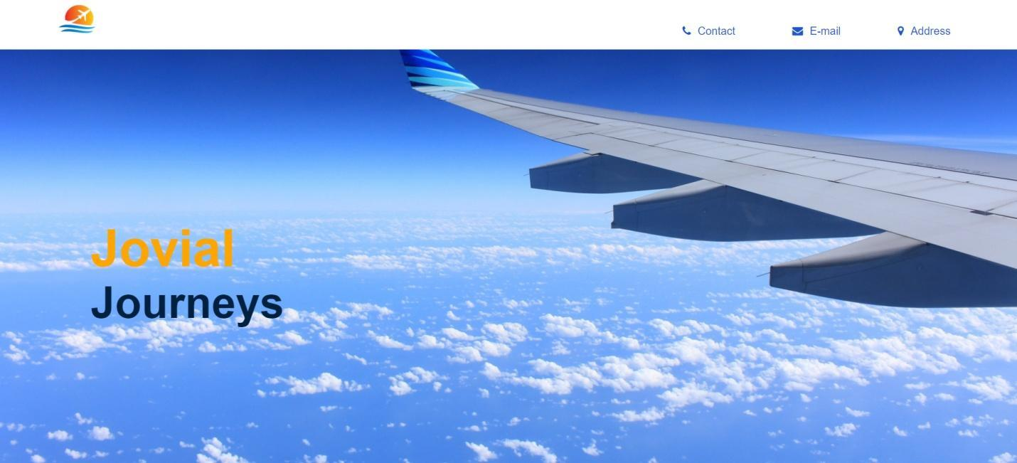

Ishaan Jain (2K18/SE/067) Dheeraj Rukwal (2K18/SE/055)

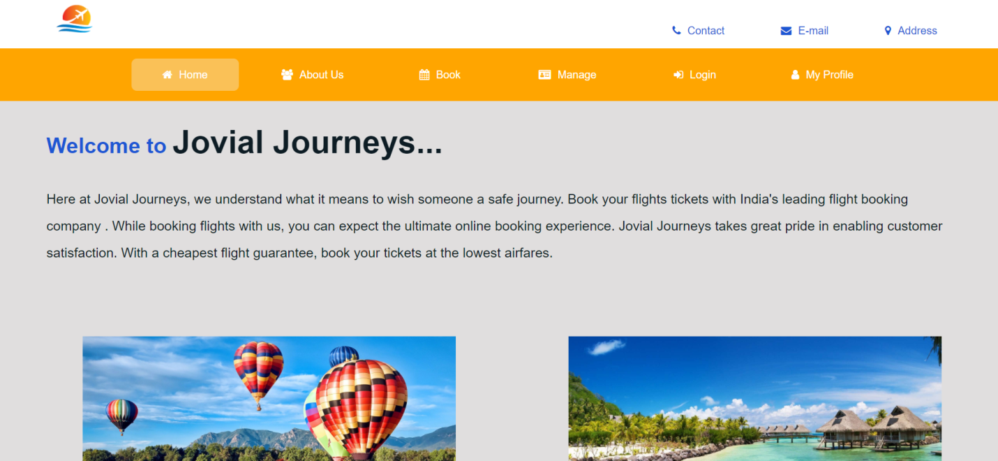

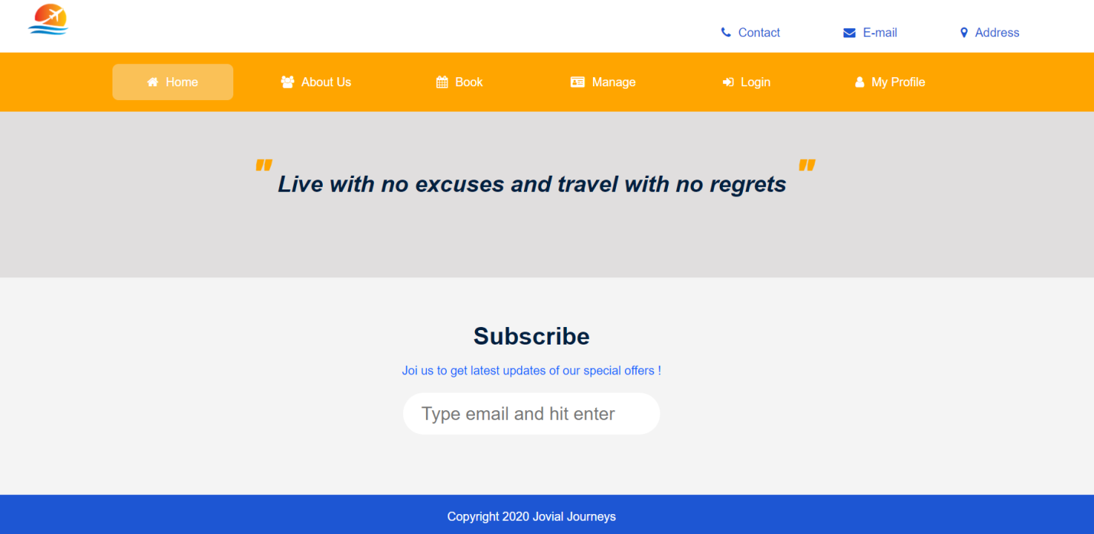

#### LOGIN INTERFACE :

The user enters his/her Username and password and is then logged into the system also if he wishes to register he can create account .

Ishaan Jain (2K18/SE/067) Dheeraj Rukwal (2K18/SE/055)

Username – Required / Alphanumeric / Exactly 6 Letters

Password – 8-15 characters long / Alphanumeric / Must contain 1 Special Character



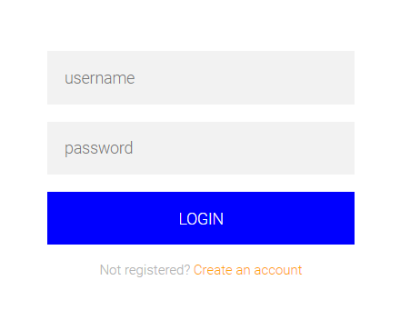

Ishaan Jain (2K18/SE/067) Dheeraj Rukwal (2K18/SE/055)

#### REGISTER INTERFACE

The user registers by entering his user type, name, email, dob, phone no. and password .On validation he/she is registered .

Password – 8-15 characters long / Alphanumeric / Must contain 1 Special Character

UserName – Required / Alphanumeric / Exactly 6 Letters

Email-Address – Required /Valid

Birth Date – Required / dd/mm/yyyy Format

User-type – Required / admin-staff-user

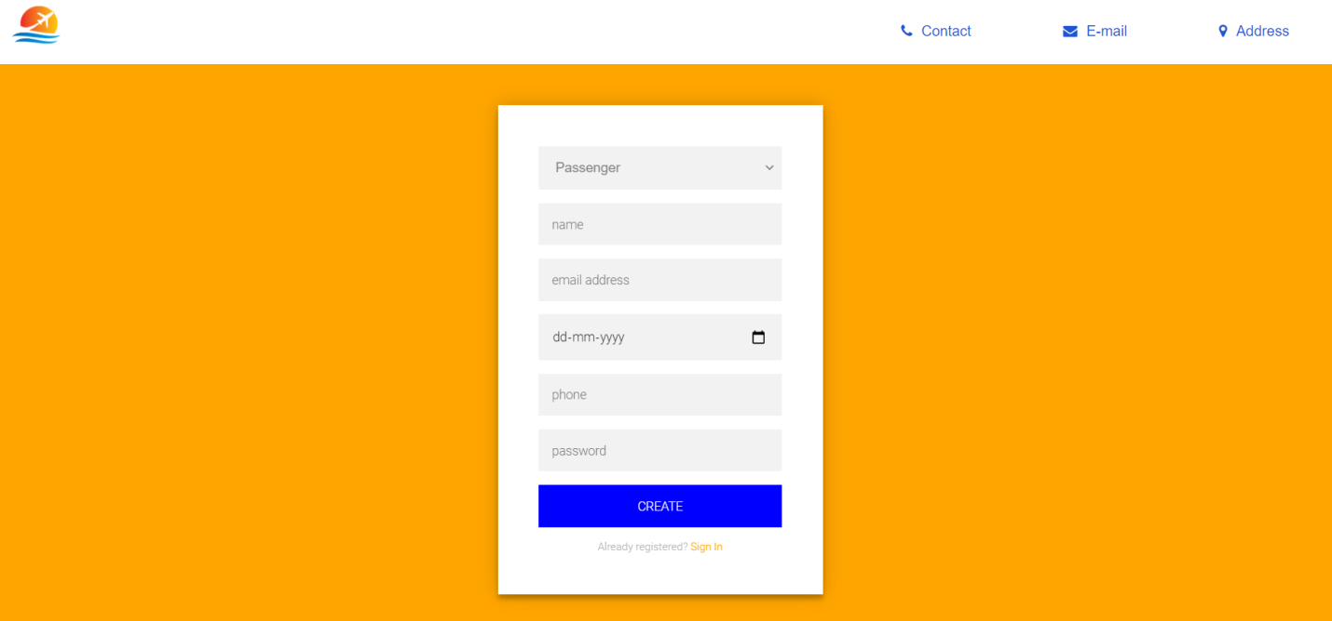

Ishaan Jain (2K18/SE/067) Dheeraj Rukwal (2K18/SE/055)

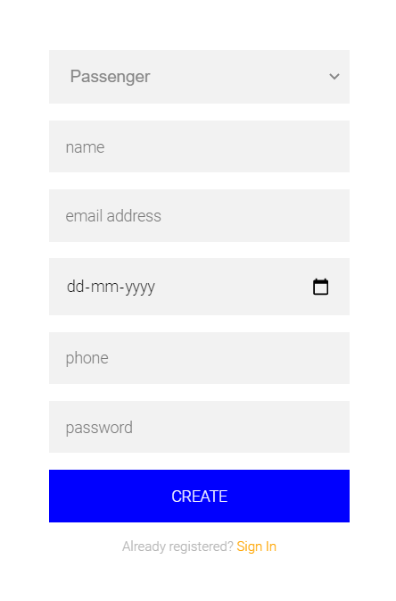

#### MY PROFILE

Once Logged in user information is displayed on this page .

Ishaan Jain (2K18/SE/067) Dheeraj Rukwal (2K18/SE/055)

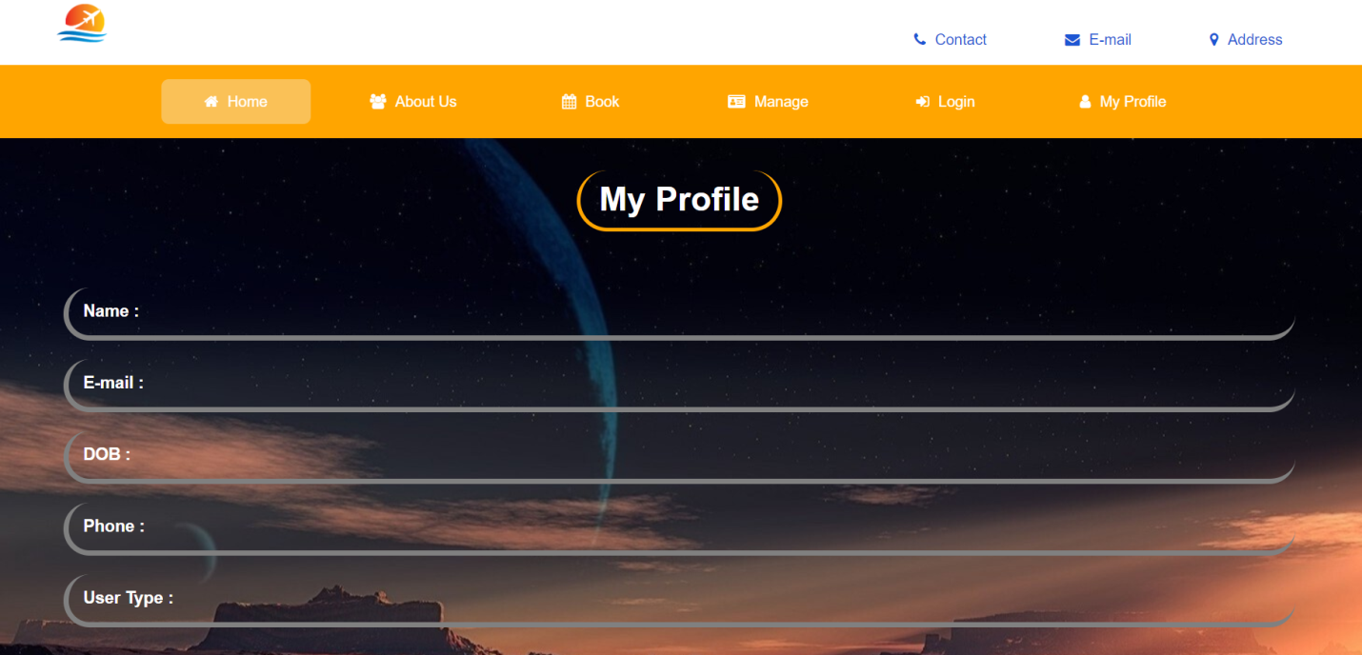

#### BOOK TICKET INTERFACE

On this page the user can select his preferences such as ticket type dates , number of tickets , cities, class etc.

Cities – Required / Travel From -> To

Dates – Must select Dates dd/mm/yyyy format

No. of Adults – Must be >=1

No. of Children – Can be >=0

Travel class – economy-business-premium

Ishaan Jain (2K18/SE/067) Dheeraj Rukwal (2K18/SE/055)

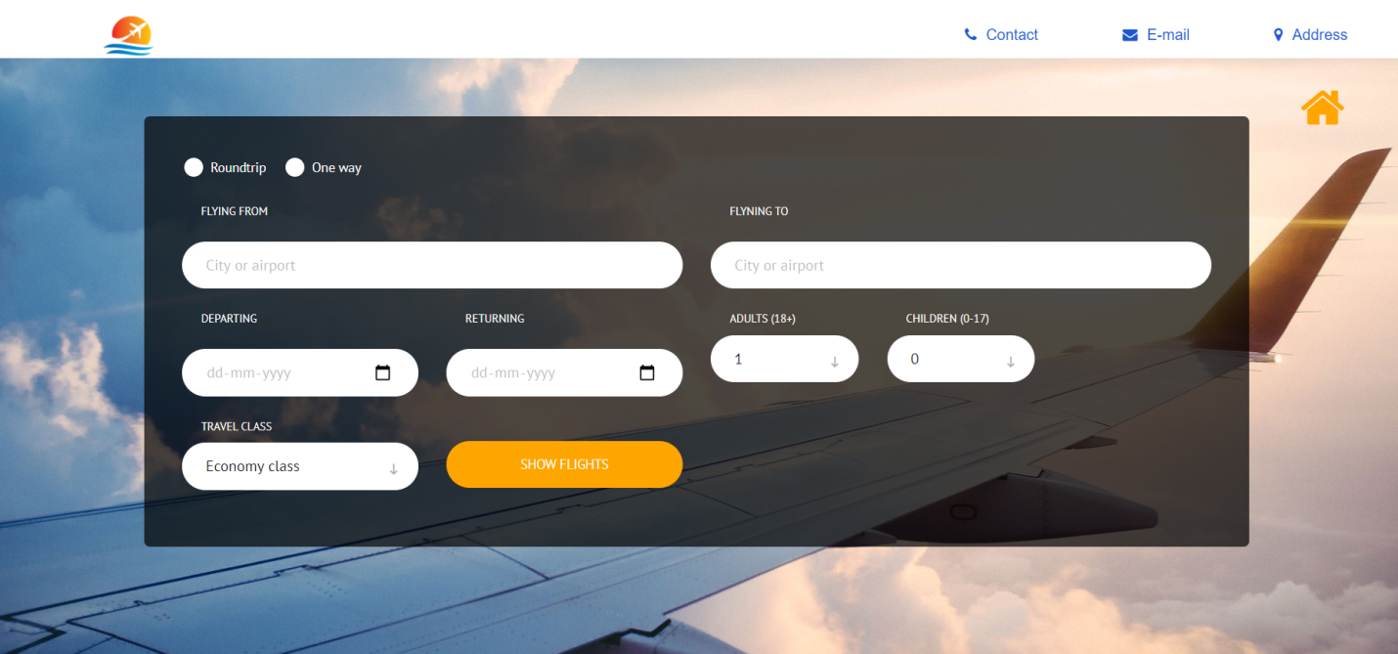

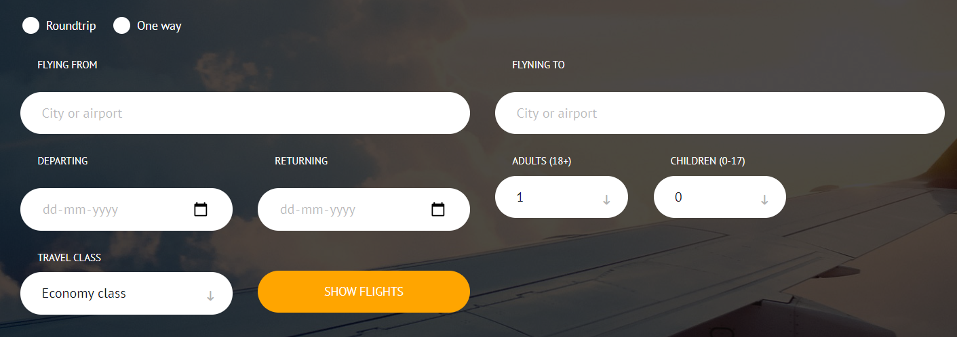

Ishaan Jain (2K18/SE/067) Dheeraj Rukwal (2K18/SE/055)

#### VIEW TICKET INTERFACE

Here User selects his preferred flight and all flights are displayed in the form of slipping tiles .

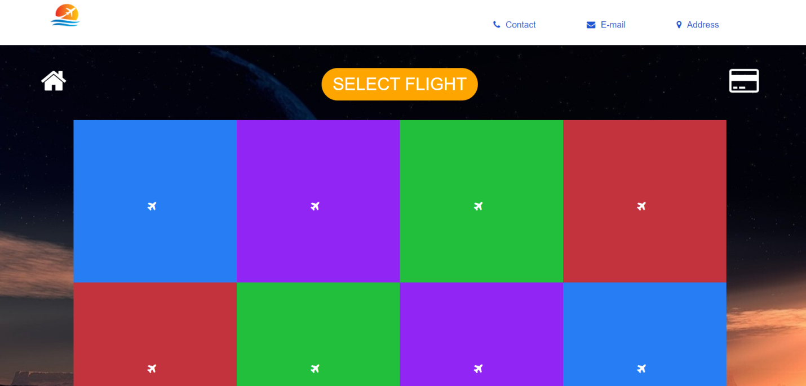



Ishaan Jain (2K18/SE/067) Dheeraj Rukwal (2K18/SE/055)

#### PAYMENT INTERFACE

On this page user makes payment via credit card by entering his payment information .

Card-Holder Name – Required / Alphabetical

Card-Number – Required / Numerical (0000 0000 0000 0000)

Expiry-Date – Required / dd/yy format

CVV – Required / Secure (***)

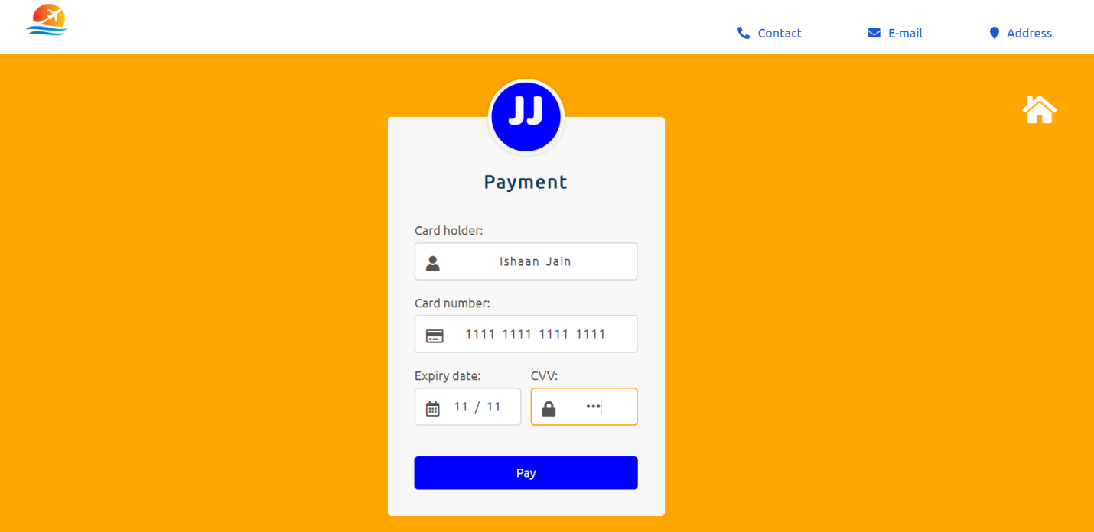

Ishaan Jain (2K18/SE/067) Dheeraj Rukwal (2K18/SE/055)

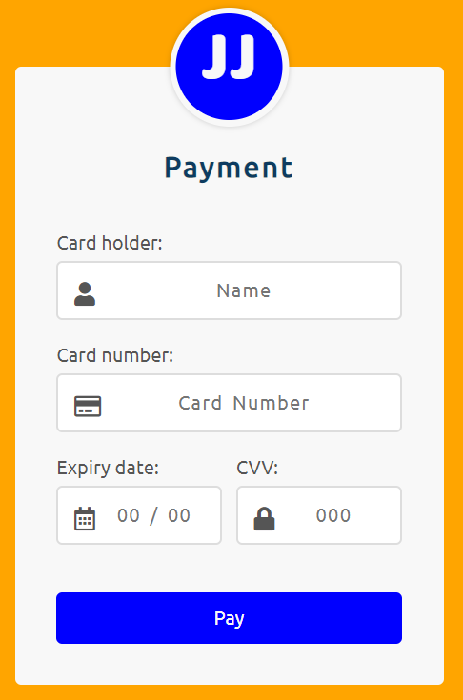

Ishaan Jain (2K18/SE/067) Dheeraj Rukwal (2K18/SE/055)

1. **ABOUT US**

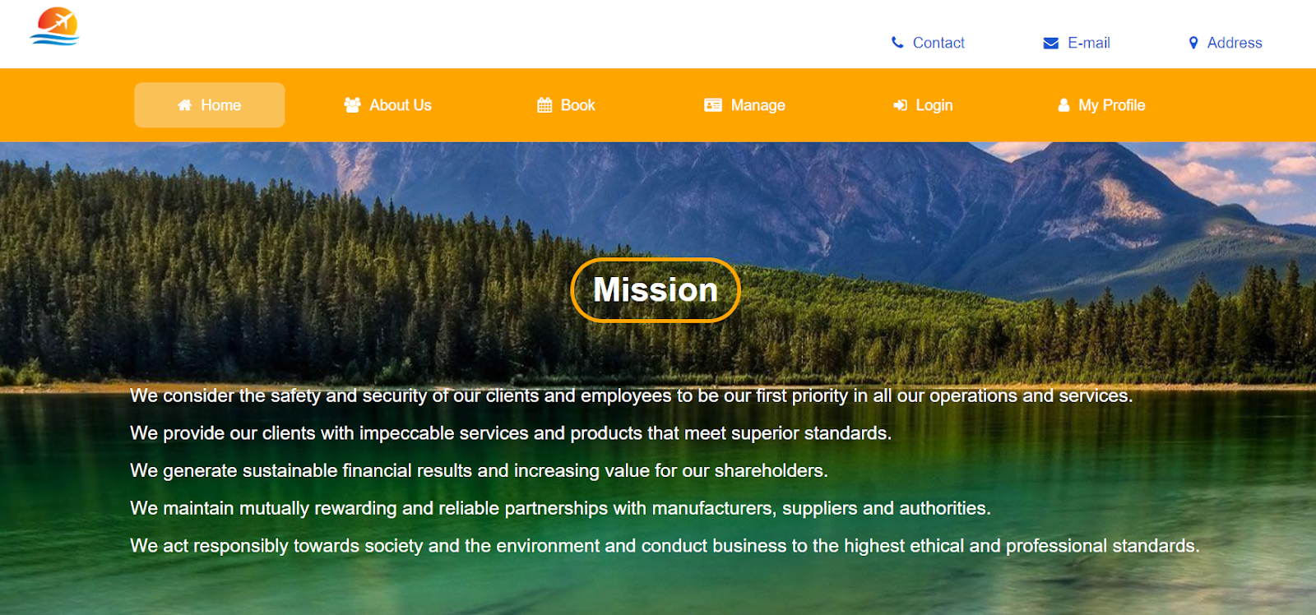



Ishaan Jain (2K18/SE/067) Dheeraj Rukwal (2K18/SE/055)

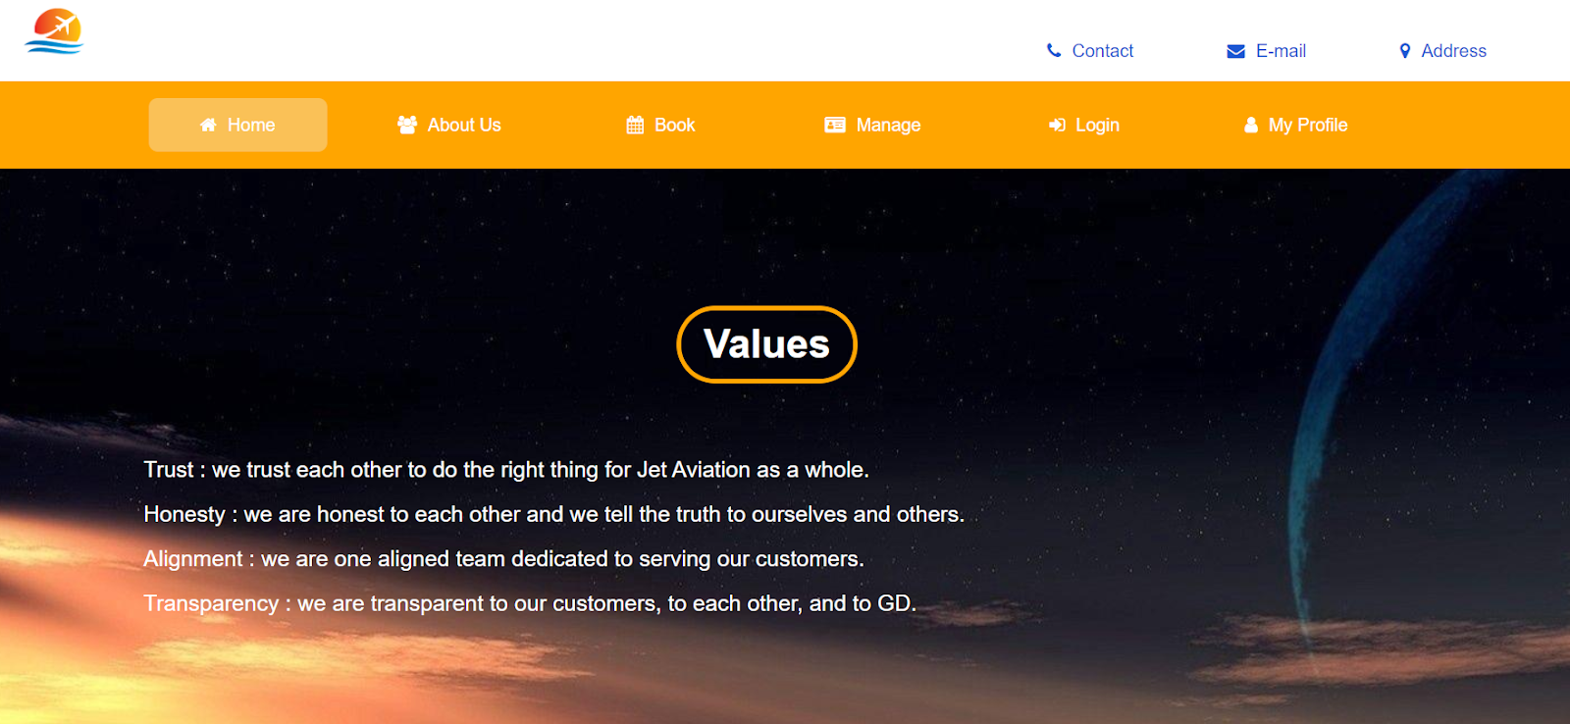

#### HARDWARE INTERFACES:

The minimum hardware requirements of Air Ticket Reservation System

( Jovial Journeys ) are a desktop that supports internet connectivity . The system must interface with the standard output device, keyboard and mouse to interact with this software, and must be connected with active internet connection.

#### SOFTWARE INTERFACES :

Air Ticket Reservation System is a Website and designed to be accessed by most of the browsers .

The Air Ticket Reservation System can be connected with MySQL .

Ishaan Jain (2K18/SE/067) Dheeraj Rukwal (2K18/SE/055)

#### COMMUNICATION INTERFACES :

Air Ticket Reservation System might require an internet connection to

Function properly and connect to databases at the backend .

### **FUNCTIONAL REQUIREMENTS**

#### LOGIN OR SIGN-UP USE CASE

|  |
| --- |
| **Introduction** : This function allows a registered passenger to login his account using his ID airline and password. If a passenger is not registered, the website shall allow the passenger to enroll first. |
| **Actors** : Passenger, Administrator, Departmental Staff |
| **Pre-Condition** : The actor must be logged to a suitable internet connection.if the passenger is already logged in he needs to log in .Other users have the option to sign up. |
| **Post-Condition** : After successful login signup passenger proceeds to flight booking page |
| **EVENT FLOW** |
| **Basic Flow** :   1. **Already Registered :** 2. The system prompts the login screen to the passenger asking for username and 3. password. 4. The passenger enters his login ID and password. 5. The system validates the actor’s password and logs him/her into the system. 6. **New Passenger :**  * If not already registered passenger registers using new credentials . * Login ID is alpha-numeric and exactly 6 character long * The password is 8-15 character long, must be alphanumeric and have at least one special character . |
| **Alternate Flow** :  **Alternate Flow 1** :  **Invalid details**   * If the passenger fills in the invalid details as in invalid login id,name or any other details then the passenger has to again fill in the details.   **Alternate Flow 2** : **Not Signed Up**   * The passenger can sign up with the system if he hasn’t enrolled before.   **Alternate Flow 3** : **Actor Terminates/Exits**   * This allows the actor to exit anytime during the use case and the state of the system remains unchanged |
| **Special Requirement** : None. |
| **Associated Use Case** : None. |

#### MAINTAIN FLIGHT DETAILS USE CASE

|  |
| --- |
| **Introduction** : This use case documents the steps that must be followed to maintain the flight details. |
| **Actors** : Administrator, Departmental Staff. |
| **Pre-Condition** : The actors must be logged into the system. |
| **Post-Condition** : The actors must be successfully able to maintain the flight details and the state of the system is changed otherwise it remains the same. |
| **EVENT FLOW** |
| **Basic** **Flow** : The actors are able to maintain the flight details as in :   * The actor enters in the details of flights as in the flights number and other details and the details regarding the flights are maintained. * Then the actor have the option of adding a flight,updating a flight details,removing a flight detail. : * **Adding a flight** : The actor can enter new flight details. * **Updating a flight** : The actor can  update existing flight details as in its timing , the route and the delays if any. * **Removing a flight** : The actor can remove the flight details in case if it is not functional or it is having another issue. |
| **Special Requirement** : None. |
| **Associated Use Case** : Login. |

#### MAINTAIN PASSENGER DETAILS USE CASE

|  |
| --- |
| **Introduction** : This use case documents the steps that must be followed to maintain the user/passenger  details. |
| **Actors** : Administrator |
| **Pre-Condition** : The actors must be logged into the system. |
| **Post-Condition** : The actors must be successfully able to maintain the passenger details and the state of the system is changed otherwise it remains the same. |
| **EVENT FLOW** |
| **Basic** **Flow** : Actors are able to log in and then various options are displayed as :   * Then the actor have the option of adding a passenger,updating a passenger details,removing a passenger detail. : * **Adding a passenger** : The actor can enter new passenger details. * **Updating a passenger** : The actor can  update existing passenger details as in its email , the number and others if any. * **Removing a passenger** : The actor can remove the passenger details in case they have cancelled the ticket or it is having another issue.   **Basic Flow 1: Add a Passenger**   * The system displays the actors to enter the details of the passenger.   These are as:   * Name * Phone Number * Age * Email Address * Address * Pin-Code   After the details are filled then the system generates a unique id to the passenger.  **Basic Flow 2:**  **Update a Passenger**   * The system requests the actors to enter the valid credentials of the passenger of whom he wishes to update the details. * The actors then enter the passenger credentials. * Then he adds the necessary changes that he wishes to update. * Once the details are updated then the system responds by displaying the changes.   **Basic Flow 3 : Remove a Passenger**   * The system prompts the actors to enter the passenger details. * The actor then enters the login credentials. * Then he deletes the user and confirms the deletion. * And the system notifies the passenger about deletion of the record. |
| **Alternate** **Flow1** : **Invalid Details**   * If the actor fills in the invalid details of the passenger then the state remains the same and the actors have to fill in the details again.   **Alternate Flow 2: Passenger Already Existed**   * If in the add passenger subflow the passenger already has an account then the system terminates by saying that the passenger already existed.   **Alternate Flow 3** : **Passenger Not Found**   * If in the remove passenger subflow is not found then the system terminates.   **Alternate Flow 4** :  **Update Cancelled**   * If in the update subflow the actors wish not to update the details then they can cancel the updates.   **Alternate Flow 5**: **Actor Terminates/Exits**   * This allows the actor to exit anytime during the use case and the state of the system remains unchanged. |
| **Special Requirement** : None. |
| **Associated Use Case** : Login. |

#### MAINTAIN STAFF DETAILS USE CASE

|  |
| --- |
| **Introduction** : This use case documents the steps that must be followed to maintain the staff  details. |
| **Actors** : Administrator. |
| **Pre-Condition** : The actor must be logged into the system. |
| **Post-Condition** : The actor must be successfully able to maintain the staff details and the state of the system is changed otherwise it remains the same. |
| **EVENT FLOW** |
| **Basic** **Flow** : The admin are able to login and  maintain the staff details as in :   * Then the actor have the option of adding a staff,updating a staff details,removing a staff detail. : * **Adding staff** : The actor can enter new staff details. * **Updating staff** : The actor can  update existing staff details as in its email , number,staff id and others if any. * **Removing staff** : The actor can remove the staff details in case they have left the system  or they have been removed.   **Basic Flow 1: Add Staff**   * The system displays the actors to enter the details of the staff to be added.   These are as:   * Name * Phone Number * Age * Email Address * Address * Pin-Code * Joining Report * Qualification   After the details are filled then the system generates a unique id to the staff member and provides him with permission to the system to make the allowed changes.  **Basic Flow 2:**  **Update staff**   * The system requests the actor to enter the valid credentials of the staff member of whom he wishes to update the details. * The actor then enters the staff member credentials. * Then he adds the necessary changes that he wishes to update. * Once the details are updated then the system responds by displaying the changes.   **Basic Flow 3 : Remove Staff**   * The system prompts the actors to enter the staff details. * The actor then enters the login credentials. * Then he deletes the staff and confirms the deletion. * And the system notifies the staff about deletion of the record. |
| **Alternate** **Flow1** : **Invalid Details**   * If the actor fills in the invalid details of the staff then the state remains the same and the actors have to fill in the details again.   **Alternate Flow 2** : **Staff Not Found**   * If in the remove staff subflow is not found then the system terminates.   **Alternate Flow 3: Staff Already Existed**   * If in the add staff subflow the staff already has an account then the system terminates by saying that the staff already existed.   **Alternate Flow 4** :  **Update Cancelled**   * If in the update subflow the actors wish not to update the details then they can cancel the updates.   **Alternate Flow 5** : **Actor Terminates/Exits**   * This allows the actor to exit anytime during the use case and the state of the system remains unchanged. |
| **Special Requirement** : None. |
| **Associated Use Case** : Login. |

#### VIEW FLIGHT DETAILS USE CASE

|  |
| --- |
| **Introduction** :   This use case documents or includes the steps that must be  followed to view the flight details. |
| **Actors** : Passenger, Administrator, Departmental Staff |
| **Pre-Condition** : The actor must be logged into the system. |
| **Post-Condition** : If the passenger is successful in adding the flight details then the state of the passenger changes and moves on to the next state otherwise the state of the system remains unchanged. |
| **EVENT FLOW** |
| **Basic Flow** :   * The system request the actor to enter his login credentials * The actor enters the flight details. * The passenger selects flight and the seat.   **Basic Flow 1: Enter the login details.**   * The actor enter the login details and then the system requests the actors to choose the option they want to choose.   **Basic Flow 2: Enter the Flight Details.**   * The actor then enters the flight details and the details of the flight is displayed to the actor. |
| **Alternate Flow** :  **Alternate Flow 1** :  **Invalid details**   * If the actor fills in the invalid details then they have to again fill in the details.   **Alternate Flow 2: Invalid Flight Details**   * If the flight details entered by the actor are invalid then the use case terminates by saying invalid flight details.   **Alternate Flow 3** : **Passenger Terminates and Exits**   * The passenger can exit anytime during the use case and the state of the system remains unchanged. |
| **Special Requirement** : None. |
| **Associated Use Case** : Login. |

#### BOOK A TICKET USE CASE

|  |
| --- |
| **Introduction** :   This use case documents or includes the steps that must be  followed for booking flight tickets. |
| **Actors** : Passenger. |
| **Pre-Condition** :     * The actor i.e the passenger must have logged into the system * The actor must have viewed flight details . |
| **Post-Condition** : If the passenger is successful in selecting flight details then the state of the passenger changes and moves on to the next state otherwise the state of the system remains unchanged. |
| **EVENT FLOW** |
| **Basic Flow** :   * The passengers choose from flight details generated from previous use case i.e view flight details . * The passenger s chooses a flight from the available list. * The passenger selects a seat and books a ticket.   **Basic Flow 1: Login to the System**   * The passenger logs into the system by entering the valid credentials.   **Basic Flow 2: View Flight Details**   * The passenger then views the flight details and chooses the flight.   **Basic Flow 3: Enter the payment details.**   * After selecting the flight the passenger then fills in his payment details and then confirms the ticket. |
| **Alternate Flow** :  **Alternate Flow 1** :  **Invalid details**   * If the passenger fills in the invalid details as in invalid flight details or the login details then the passenger has to again fill in the details.   **Alternate Flow 2** : **Seat Availability**   * The passenger will have to reselect the seats if no seats are available corresponding to given travel dates .   **Alternate Flow 3: Invalid Payment/Bank Details**   * If the passenger fills in the wrong bank details then the use case terminates by saying invalid bank or payment details.   **Alternate Flow 4** : **Passenger Terminates and Exits**   * The passenger can exit anytime during the use case and the state of the system remains unchanged. |
| **Special Requirement** : None. |
| **Associated Use Case** : View Flight Details,Login,Payment. |

#### PAYMENT USE CASE

|  |
| --- |
| **Introduction** :   This use case documents or includes the steps that must be  followed to pay for the flight ticket |
| **Actors** : Passenger. |
| **Pre-Condition** :   * The actor i.e the passenger must be logged into the system * The actor i.e the passenger must have booked tickets . |
| **Post-Condition** : If the passenger is successful in making payment corresponding to his flight, the tickets are generated . |
| **EVENT FLOW** |
| **Basic Flow** :   * The passengers checks his selected flight before making payment and proceeds . * Customer selects mode of transaction and makes payment * On success a confirmation message is generated |
| **Alternate Flow** :  **Alternate Flow 1** :  **Invalid transaction details**   * If the passenger fills in the invalid payment details then the use case terminates and passenger needs to re-initiate the transaction.   **Alternate Flow 2** : **Passenger Terminates and Exits**   * The passenger can exit anytime during the use case and the transaction will be cancelled. |
| **Special Requirement** : None. |
| **Associated Use Case** : Book tickets. |

#### ADD LUGGAGE DETAILS USE CASE

|  |
| --- |
| **Introduction** :   This use case documents or includes the steps that must be  followed for adding the luggage details . |
| **Actors** : Passenger. |
| **Pre-Condition** :   * The actor i.e the passenger must be logged into the system, * The actor must have made payment. |
| **Post-Condition** : If the passenger is successful in adding the luggage details then the state of the passenger changes and moves on to the next state otherwise the state of the system remains unchanged. |
| **EVENT FLOW** |
| **Basic Flow** :  The passengers adds no. of items and their basic description such as colour, type, size etc. |
| **Alternate Flow** :  **Alternate Flow 1** :  **Invalid details**   * If the passenger fills in the invalid details as entering 2 luggage items and entering details of 3 items then the passenger has to again fill in the details.   **Alternate Flow 2** : **Passenger Terminates and Exits**   * The passenger can exit anytime during the use case and the state of the system remains unchanged. |
| **Special Requirement** : None. |
| **Associated Use Case** : Payment. |

#### ADD PASSPORT DETAILS USE CASE

|  |
| --- |
| **Introduction** :   This use case documents or includes the steps that must be  followed by adding the passport details. |
| **Actors** : Passenger. |
| **Pre-Condition** :   * The actor i.e the passenger must be logged into the system, * The actor must have made payment. |
| **Post-Condition** : If the passenger is successful in adding the passport details then the state of the passenger changes and moves on to the next state otherwise the state of the system remains unchanged. |
| **EVENT FLOW** |
| **Basic Flow** :   * The passengers logs into the system and chooses the add passport option * The passengers add their passport details into the system. |
| **Alternate Flow** :  **Alternate Flow 1** :  **Invalid details**   * If the passenger fills in the invalid details as in invalid login id,name or any other passport details then the passenger has to again fill in the details.   **Alternate Flow 2** : **Passenger Terminates and Exits**   * The passenger can exit anytime during the use case and the state of the system remains unchanged. |
| **Special Requirement** : None. |
| **Associated Use Case** : Payment,Book Ticket. |

#### CANCEL FLIGHT TICKET USE CASE

|  |
| --- |
| **Introduction:** This use case includes the steps that must be followed to cancel the ticket. |
| **Actors** : Administrator, Passenger. |
| **Pre-Condition** :   * The actors must be logged into the system. * The passenger should have made payment. |
| **Post-Condition** : The actors are able to cancel the flight ticket and the state of their travelling changes and if they are not able to cancel the ticket then the state remains unchanged. |
| **EVENT FLOW** |
| **Basic Flow** :   * The passenger fills in their details and then various options are displayed; they then choose the cancel ticket option and apply for the refund. * If the admin is cancelling the passenger ticket he then enters their details and cancels the ticket providing the passenger with an update along with a reason. |
| **Alternate Flow 1** :  **Invalid Details** :   * If the actors fill in the invalid details then they have to re-enter their details.   **Alternate Flow 2**  : **Actor Terminates/Exits** :   * This allows the actors to exit the system at any state and the state of their ticket remains unchanged. |
| **Special Requirement** : None. |
| **Associated Use Case** : Payment. |

#### REFUND USE CASE

|  |
| --- |
| **Introduction** :   This use case documents or includes the steps that must be  followed to refund the passenger his amount. |
| **Actors** : Administrator |
| **Pre-Condition** :   * The actor i.e the administrator must be logged into the system * The passenger has cancelled the ticket . |
| **Post-Condition** : If the passenger had made payment and cancelled the flight ticket then his amount is refunded . |
| **EVENT FLOW** |
| **Basic Flow** :   * The administrator verifies passenger details and flight details from the cancel ticket and initiates refund . * The amount is refunded after deducting penalty charges |
| **Alternate Flow** :  **Alternate Flow 1** :  **Invalid details**   * If the passenger filled in the invalid details i.e payment not made or invalid flight details then the refund is cancelled .   **Alternate Flow 2** : **Passenger Terminates and Exits**   * The passenger can exit anytime during the use case and the state of the system remains unchanged. |
| **Special Requirement** : None. |
| **Associated Use Case** : Cancel ticket. |

Ishaan Jain (2K18/SE/067) Dheeraj Rukwal (2K18/SE/055)

### **PERFORMANCE REQUIREMENTS**

System should be able to handle 1000 transactions per second

### **RELIABILITY CONSTRAINTS**

* System’s Service Level Agreement (SLA) level should be of 98%.
* Maximum 2 of 1000 online payment transactions through the systems can result in failure.

### **SECURITY REQUIREMENTS**

* System should have an Authentication and Authorization System (AAS) for logins.
* System should grant administrative privileges only to the one who logins with predefined administrative username and password.
* System should allow administrator to change his/her system-generated password as he/she wishes.
* System should allow administrator to login with customized password.
* System should block access to one who fails to login three time in a row.
* System should guarantee the security of communication channel.
* Customized password should be at least 8 characters.
* Customized password should contain both letters and numbers

### **MAINTAINABILITY REQUIREMENTS**

* User should be displayed acceptance message within 5 seconds, when he/she submits entered data to the system.
* Warning messages about entrance data out of defined standards must remain on the screen for 3 seconds.

Ishaan Jain (2K18/SE/067) Dheeraj Rukwal (2K18/SE/055)

### **PORTABILITY**

System should be manageable in web-browsers of Internet Explorer, Google Chrome, Mozilla Firefox, Opera and Safari.

### **OTHER REQUIREMENTS**

* System should display a warning message if the customer input for full name label is out of defined standard.
* System should display a warning message if the customer input for travel document number is out of defined standard.
* System should display a warning message if the customer wants to book flights for more than 6 people.
* System should display a warning message

## **SYSTEM FEATURES**

### **LOGIN / SIGN-UP**

* This function allows a registered user to login his account using his frequent flyer number with the airline and password. If a user is not registered, the website shall allow the user to enroll first. The system will check both the frequent flight number and password, when a user attempts to login.

Ishaan Jain (2K18/SE/067) Dheeraj Rukwal (2K18/SE/055)

* This provides security to the system by authenticating each member and provides confidence to the consumer that his/her personal information is secure

### **VIEW FLIGHT**

The user can use the View Ticket function to view the booked tickets. Every information about the ticket which is booked by the user will be shown by this function such as time of booking, no of tickets, details of passenger, source and destination, class of ticket, payment details etc.

### **BOOK TICKET**

* The user can use the Book Ticket function to purchase seats for an airplane flight. The system shall present the user with information on all current flights. The user may then select a pair (departure and return) of flights on which to purchase seats. The user can indicate the number of seats and placement of such. Finally, the system shall guide the user completely through the checkout process.
* The heart of the business is selling seats on flights. This section provides the primary source of system transactions.

Ishaan Jain (2K18/SE/067) Dheeraj Rukwal (2K18/SE/055)

### **CANCEL**

The user can use the Cancel Ticket function to cancel the already booked tickets for an airplane flight. The system shall present the user with information on which tickets to be canceled if booked more number of tickets from a single account . The user may then select the corresponding ticket of flight, which needs to be cancelled. Finally, the system shall guide the user through the cancellation process and refund policy.

### **REFUND**

* The user can use the Refund Cancelled Ticket function to get a refund for the already booked tickets for an airplane flight.
* Also the admin can use this feature to get insight into the stages and status of refund .

Ishaan Jain (2K18/SE/067) Dheeraj Rukwal (2K18/SE/055)

**CLASS DIAGRAM**

**(AIR TICKET RESERVATION SYSTEM)**

**Classes :**

1. **Entity Classes :**
2. Staff Entity
3. Passenger Entity
4. Admin Entity
5. Flight Entity
6. Payment Entity
7. Passport, Luggage Entity
8. **Interface Classes :**
9. Login Interface
10. Register Interface
11. Book Ticket Interface
12. Payment Interface
13. Maintain Staff Interface
14. Maintain Passenger Interface
15. Maintain Flight Interface
16. View Interface
17. Passport Luggage Interface
18. **Control Classes :**
19. Login
20. Register
21. Book Ticket
22. Payment

Ishaan Jain (2K18/SE/067) Dheeraj Rukwal (2K18/SE/055)

1. Maintain Staff
2. Maintain Passenger
3. Maintain Flight
4. View
5. Passport Luggage

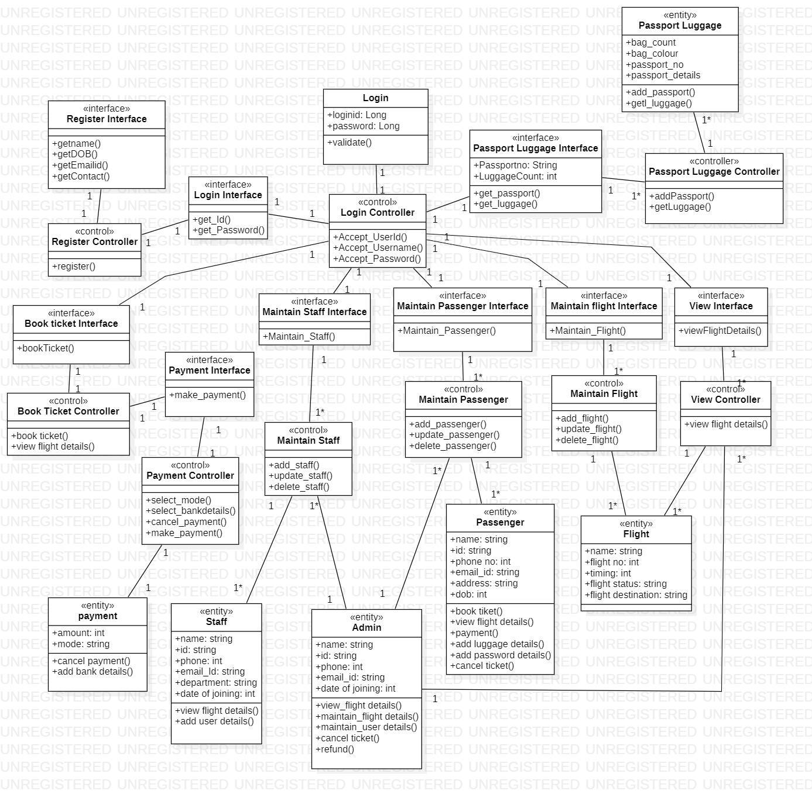

Ishaan Jain (2K18/SE/067) Dheeraj Rukwal (2K18/SE/055)

**SEQUENCE DIAGRAM**

**(AIR TICKET RESERVATION SYSTEM)**

1. **LOGIN AND SIGNUP SEQUENCE DIAGRAM**

**BASIC FLOW :**

* 1. Actor Logs into the system

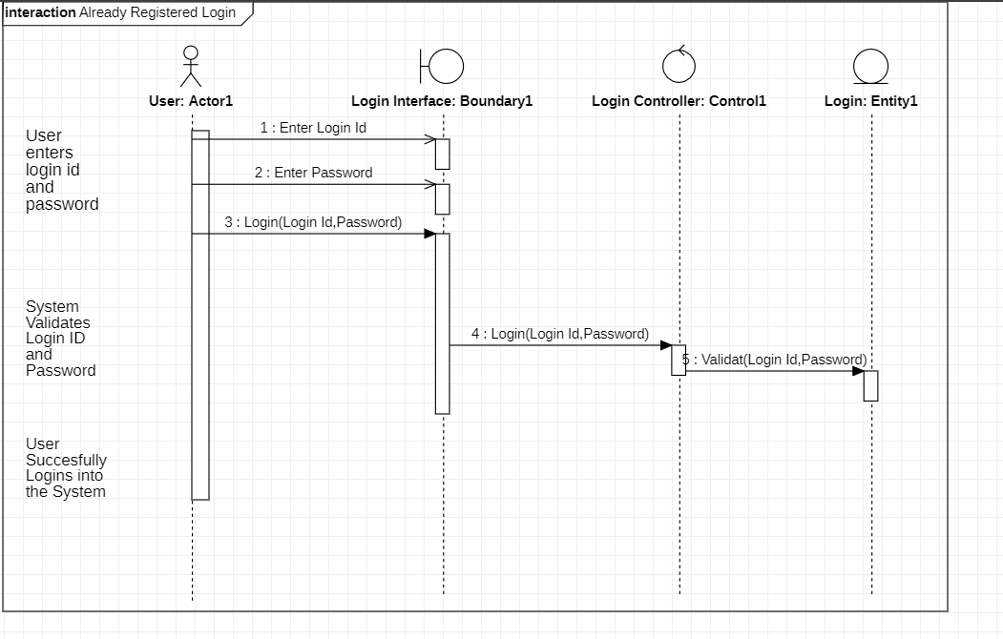

Ishaan Jain (2K18/SE/067) Dheeraj Rukwal (2K18/SE/055)

* 1. Actor tries to sign up into the system

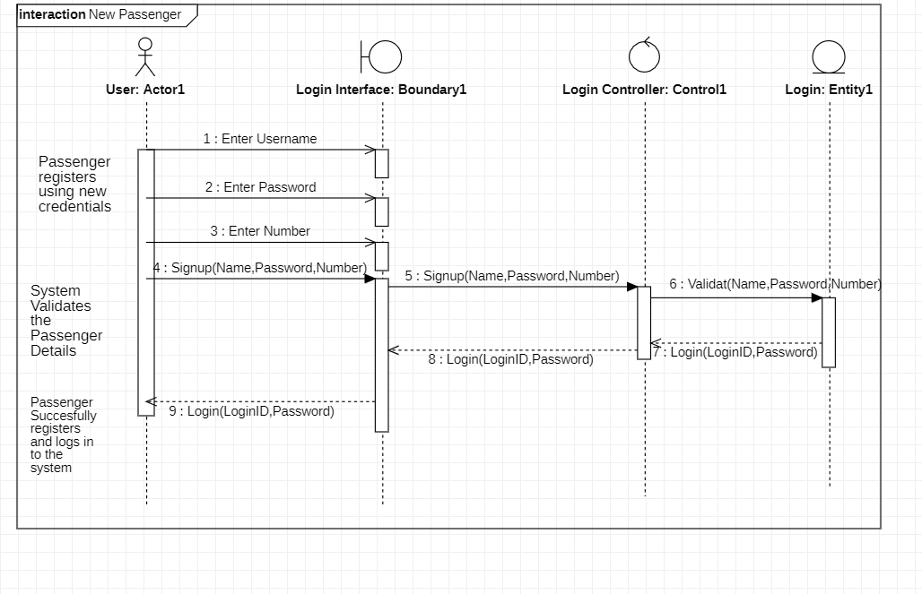

Ishaan Jain (2K18/SE/067) Dheeraj Rukwal (2K18/SE/055)

**ALTERNATE FLOW :**

* 1. Invalid Details

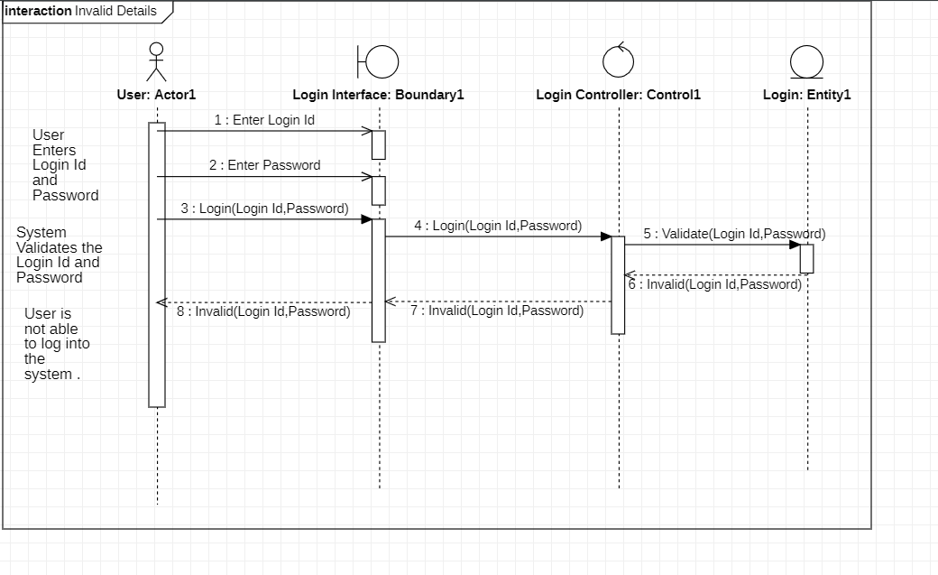

Ishaan Jain (2K18/SE/067) Dheeraj Rukwal (2K18/SE/055)

* 1. User Already Exist

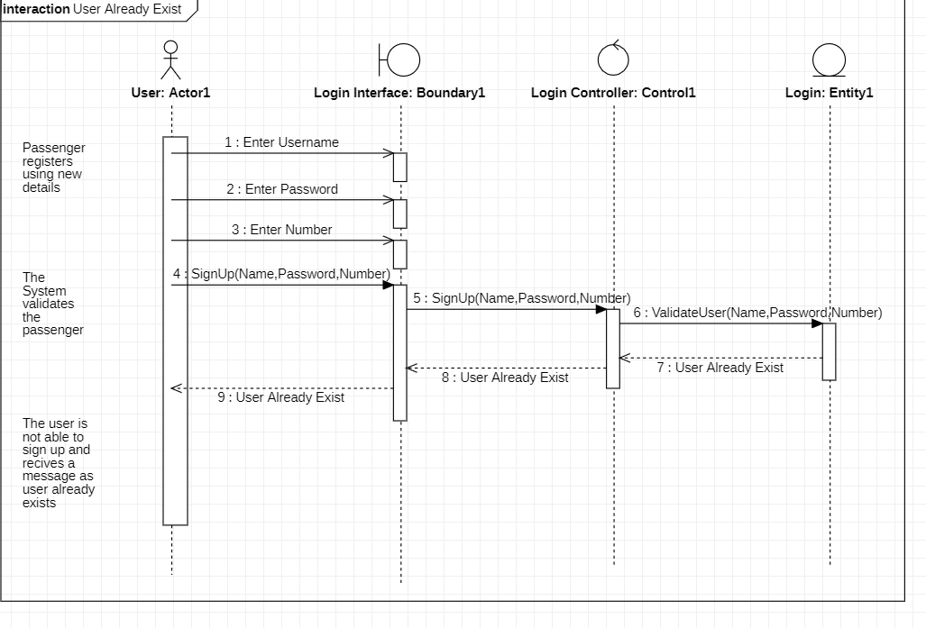

Ishaan Jain (2K18/SE/067) Dheeraj Rukwal (2K18/SE/055)

1. **BOOK TICKETS SEQUENCE DIAGRAM**

**BASIC FLOW**

2.1 Enter

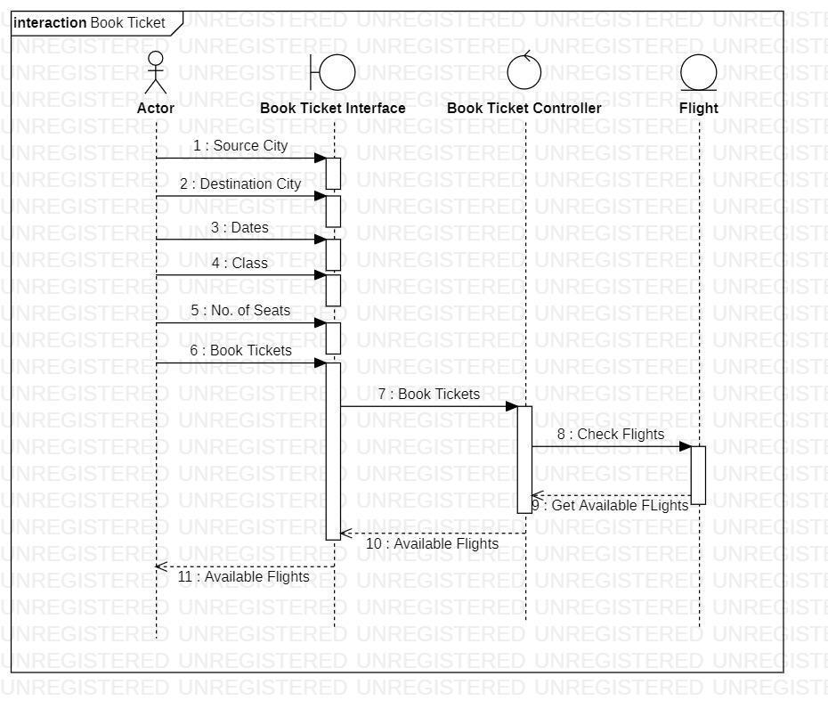

Ishaan Jain (2K18/SE/067) Dheeraj Rukwal (2K18/SE/055)

**ALTERNATE FLOW**

2.2 Invalid Details

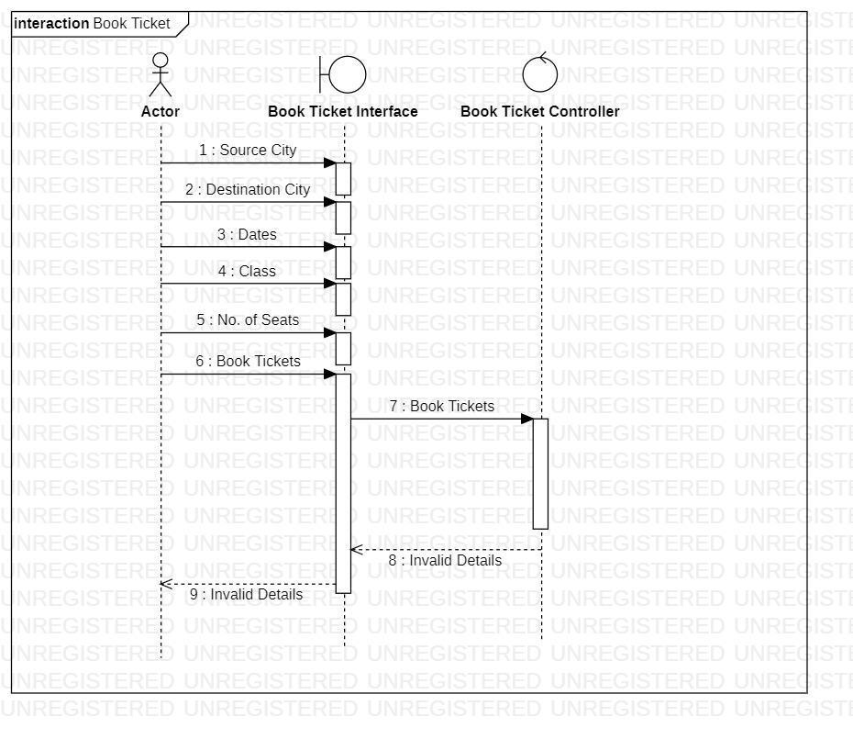

Ishaan Jain (2K18/SE/067) Dheeraj Rukwal (2K18/SE/055)

2.3 No flights available for selected Details

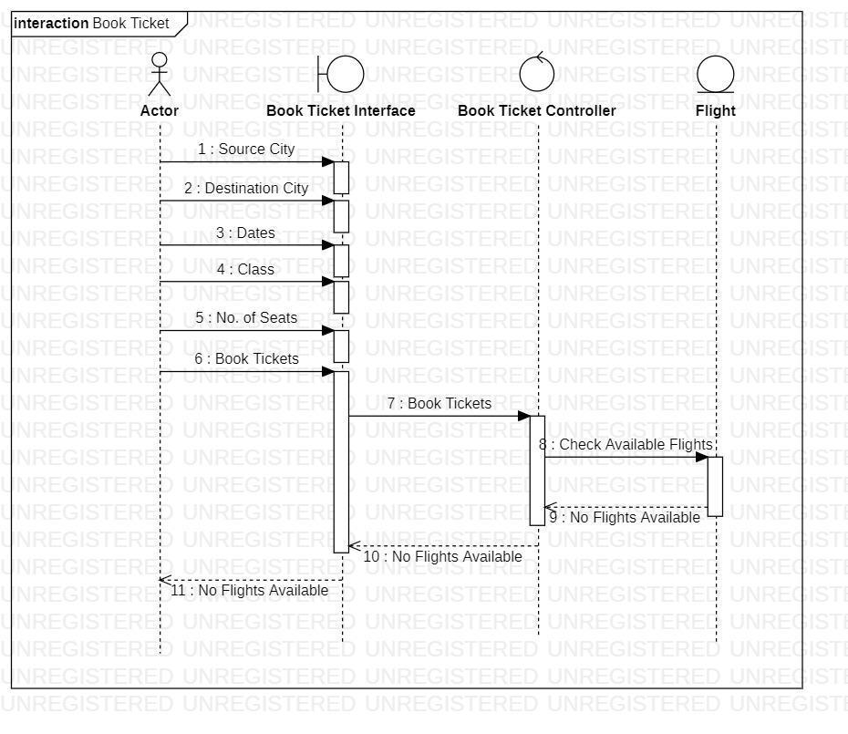

Ishaan Jain (2K18/SE/067) Dheeraj Rukwal (2K18/SE/055)

1. **VIEW TICKETS SEQUENCE DIAGRAM**

**BASIC FLOW**

3.1 Enter Details and view flights

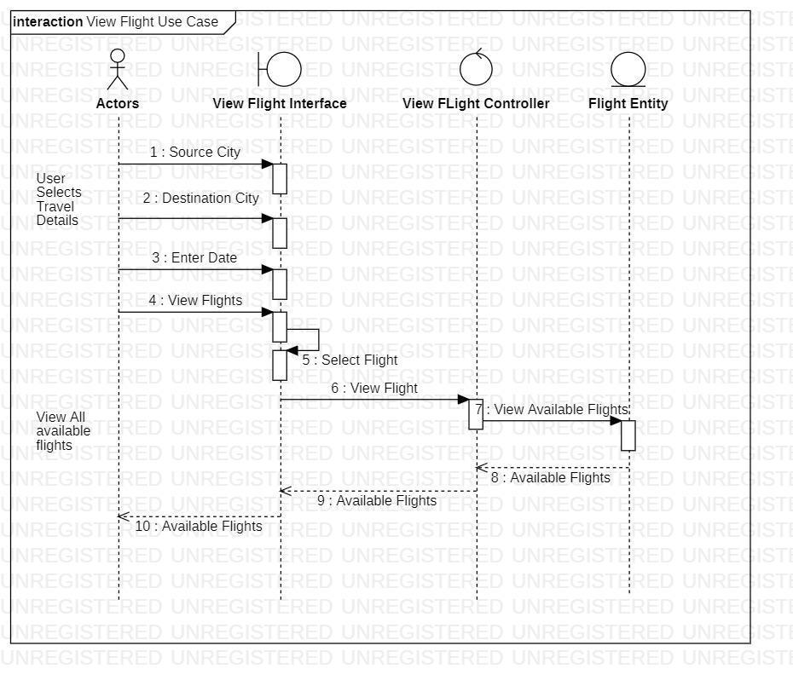

Ishaan Jain (2K18/SE/067) Dheeraj Rukwal (2K18/SE/055)

**ALTERNATE FLOW**

3.2 Source / Destination City is empty

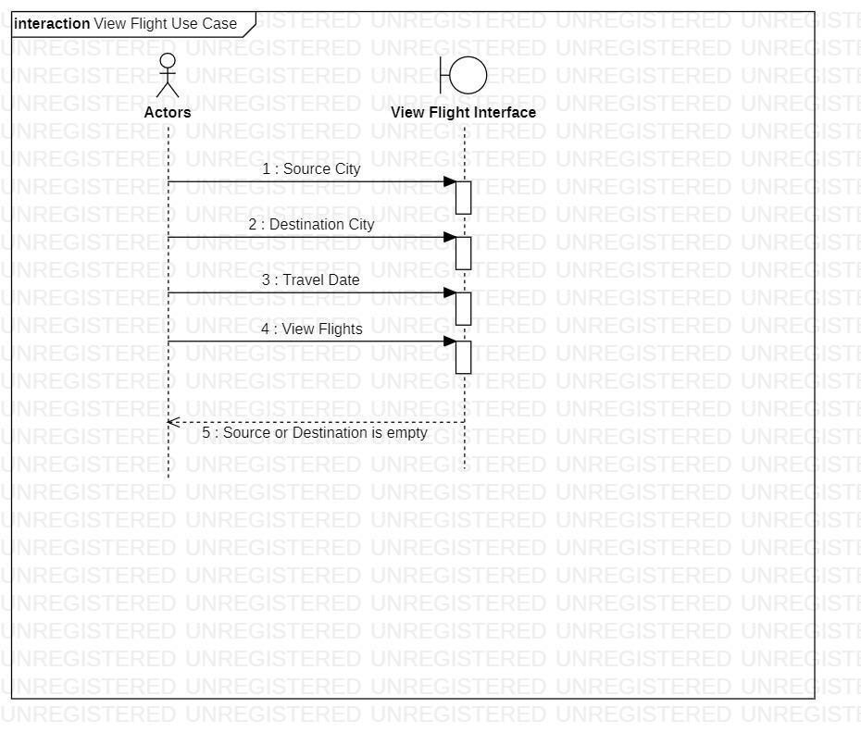

Ishaan Jain (2K18/SE/067) Dheeraj Rukwal (2K18/SE/055)

3.3 Travel Date is empty

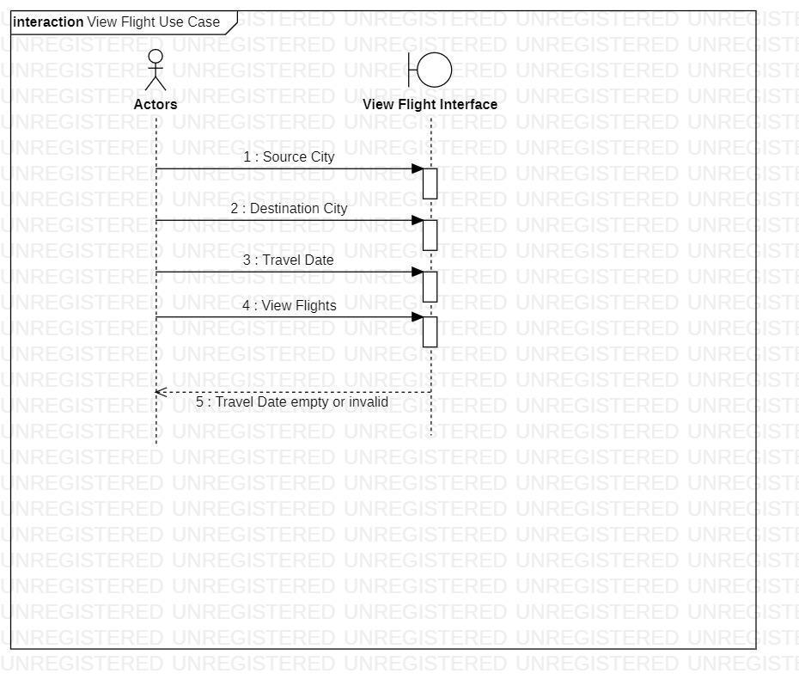

Ishaan Jain (2K18/SE/067) Dheeraj Rukwal (2K18/SE/055)

1. **MAKE PAYMENT SEQUENCE DIAGRAM**

**BASIC FLOW**

4.1 Add Payment details and make payment

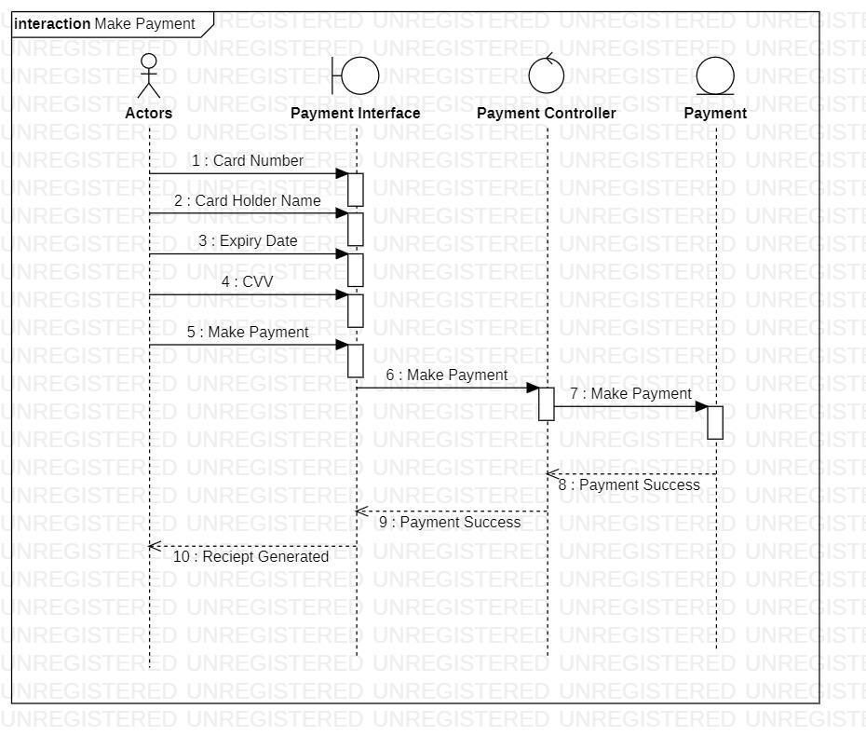

Ishaan Jain (2K18/SE/067) Dheeraj Rukwal (2K18/SE/055)

**ALTERNATE FLOW**

4.2 Invalid Payment Details

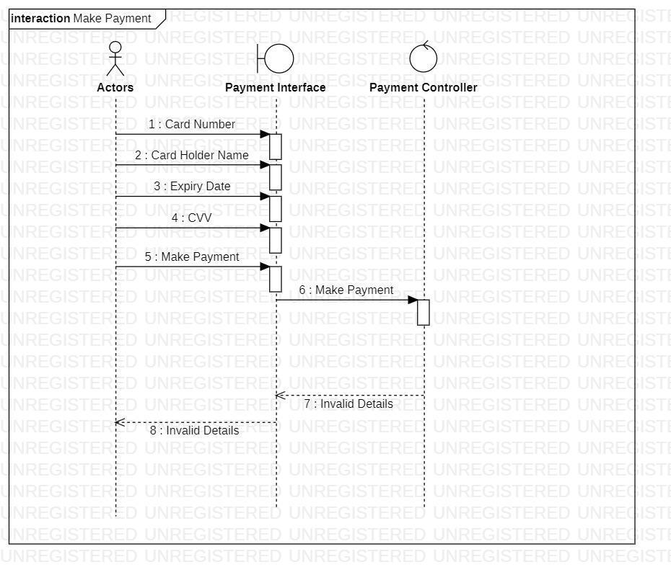

Ishaan Jain (2K18/SE/067) Dheeraj Rukwal (2K18/SE/055)

4.3 Time Exceeded – Transaction cancelled

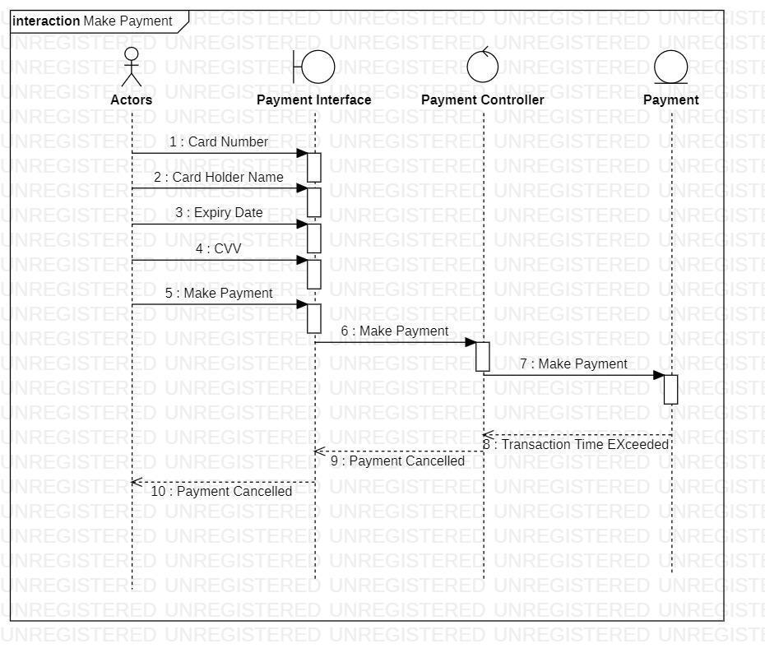

Ishaan Jain (2K18/SE/067) Dheeraj Rukwal (2K18/SE/055)

1. **CANCEL TICKETS SEQUENCE DIAGRAM**

**BASIC FLOW**

5.1 Cancel booked tickets

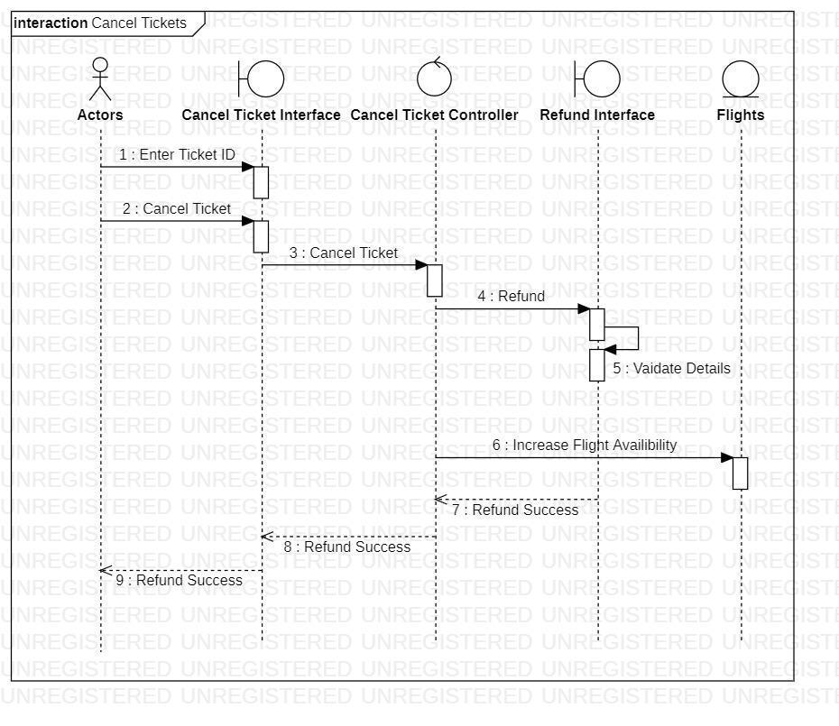

Ishaan Jain (2K18/SE/067) Dheeraj Rukwal (2K18/SE/055)

**ALTERNATE FLOW**

5.2 Invalid Details

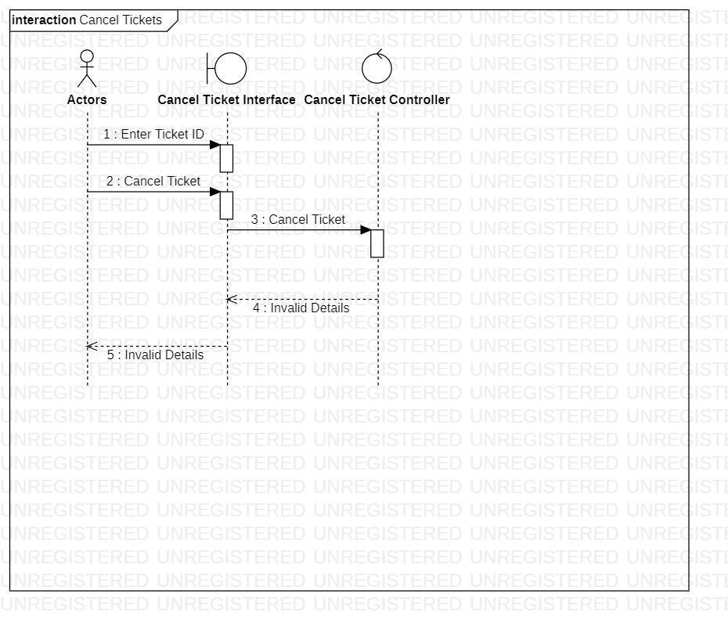

Ishaan Jain (2K18/SE/067) Dheeraj Rukwal (2K18/SE/055)

1. **REFUND SEQUENCE DIAGRAM**

**BASIC FLOW**

6.1 Refund paid amount for flight

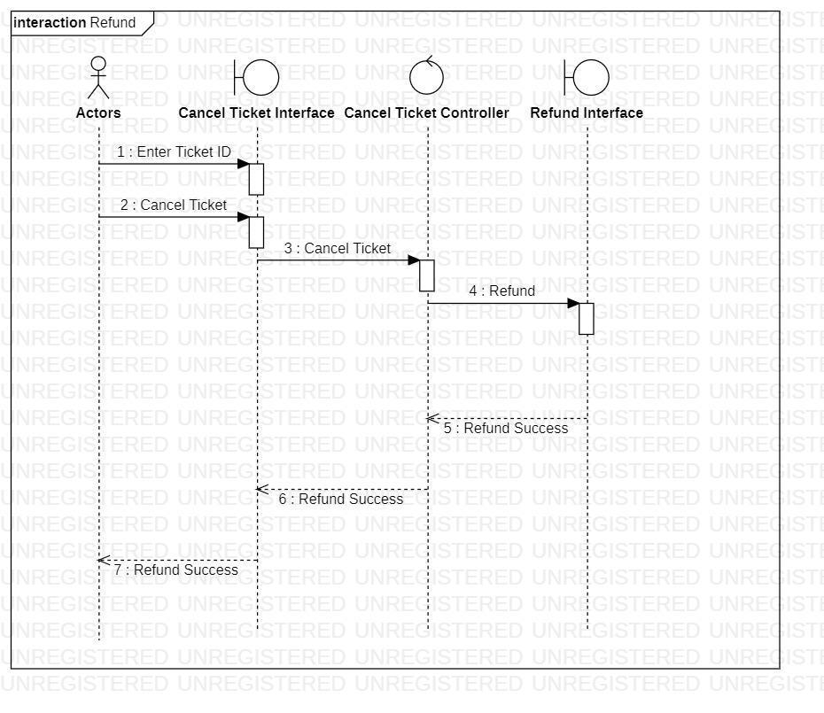

Ishaan Jain (2K18/SE/067) Dheeraj Rukwal (2K18/SE/055)

**ALTERNATE FLOW**

6.2 Invalid details of payment

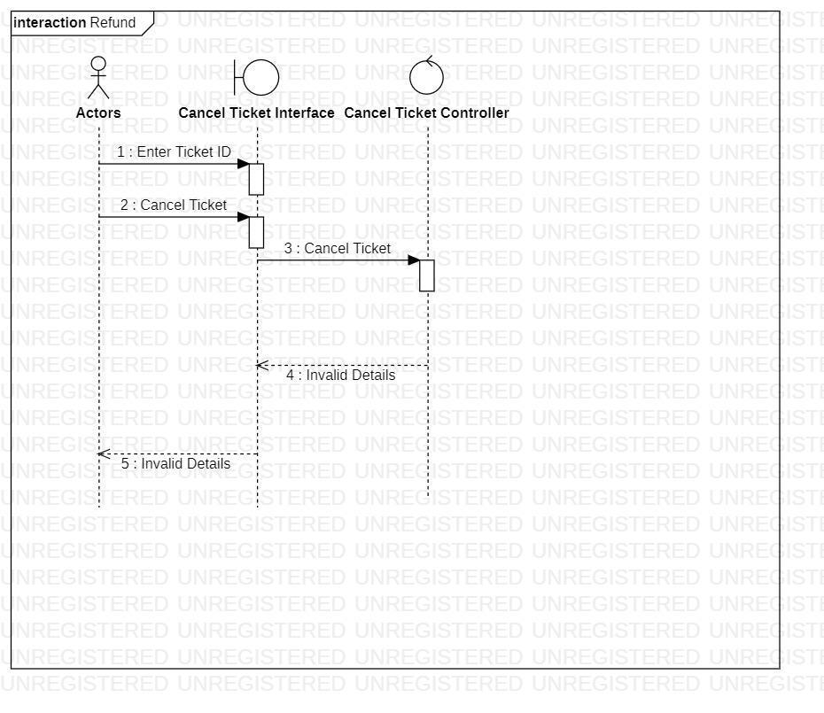

Ishaan Jain (2K18/SE/067) Dheeraj Rukwal (2K18/SE/055)

7. **ADD LUGGAGE SEQUENCE DIAGRAM**

Basic Flow

7.1 Add Luggage

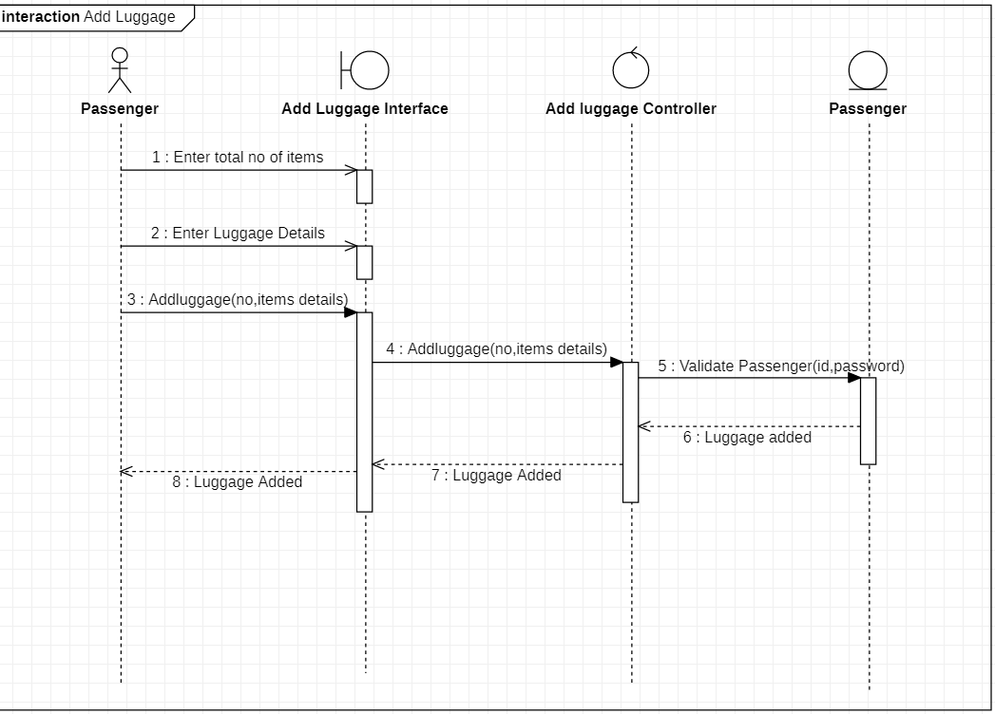

Ishaan Jain (2K18/SE/067) Dheeraj Rukwal (2K18/SE/055)

Alternate Flow

7.2 Invalid Details

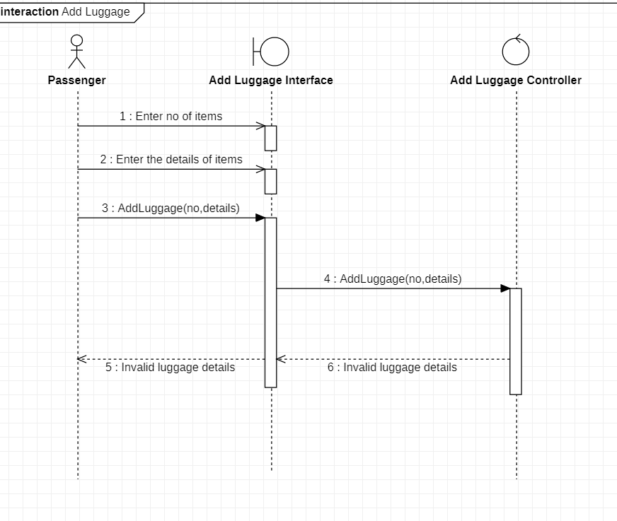

Ishaan Jain (2K18/SE/067) Dheeraj Rukwal (2K18/SE/055)

7.3 User Exits

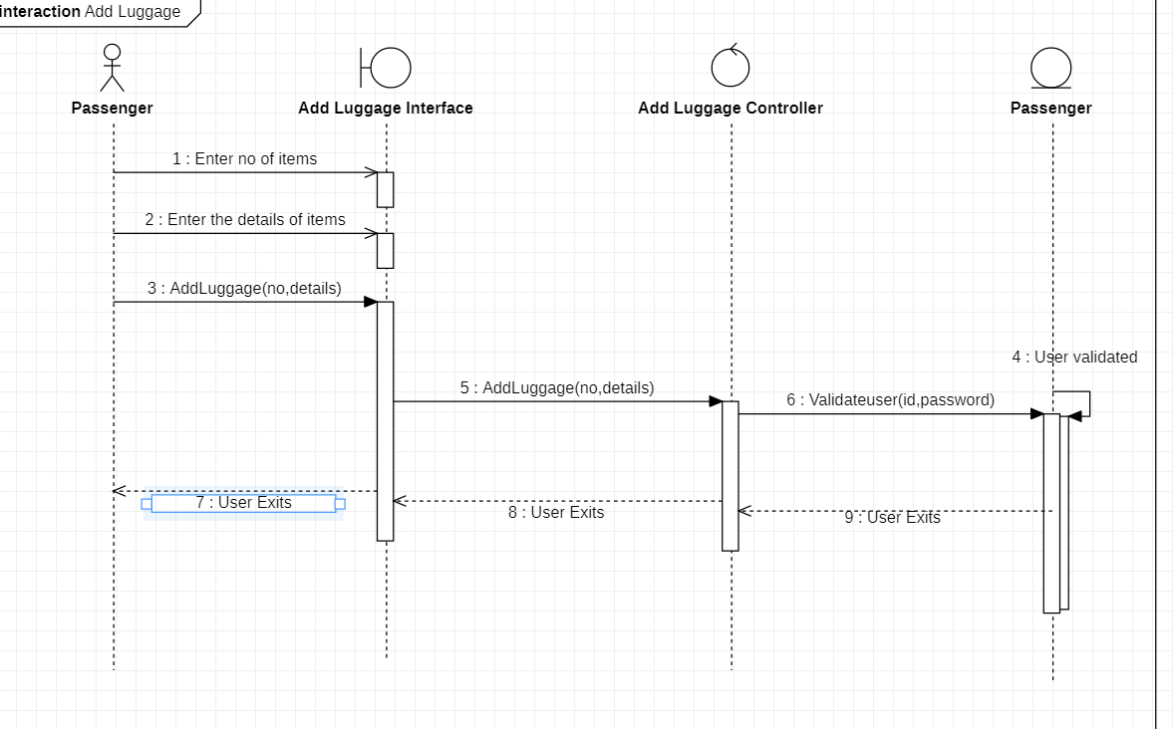

8. **ADD PASSPORT**

Basic Flow

Ishaan Jain (2K18/SE/067) Dheeraj Rukwal (2K18/SE/055)

8.1 Passenger adds passport details

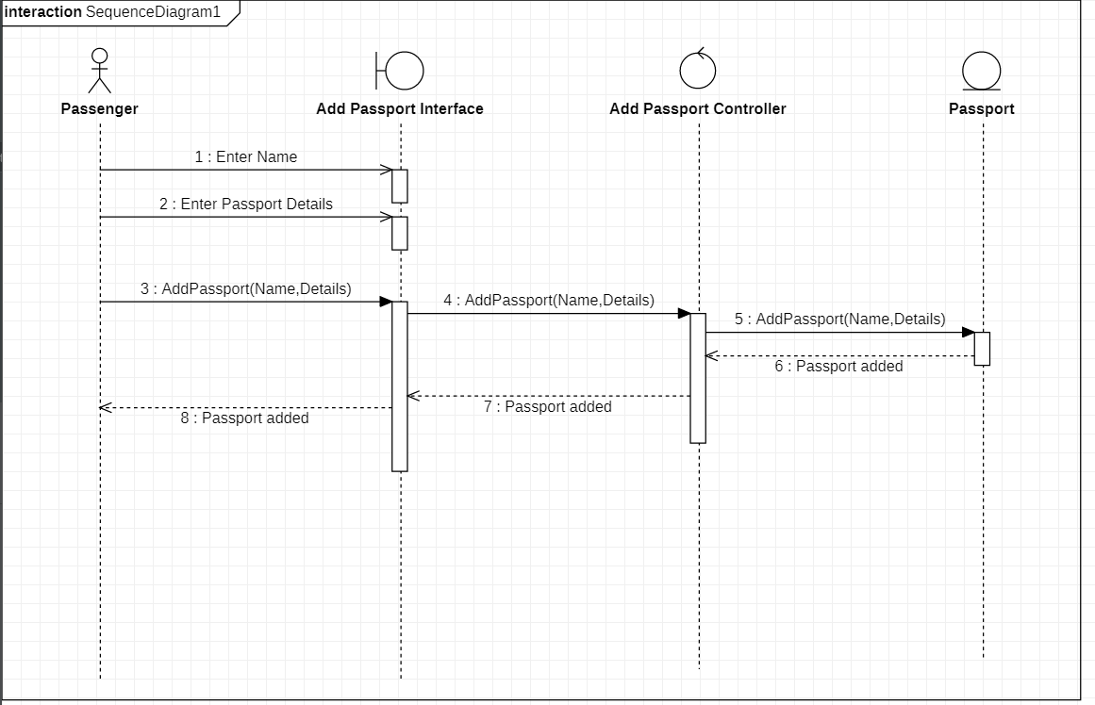

Ishaan Jain (2K18/SE/067) Dheeraj Rukwal (2K18/SE/055)

Alternate FLow

8.2 Invalid Passport Details

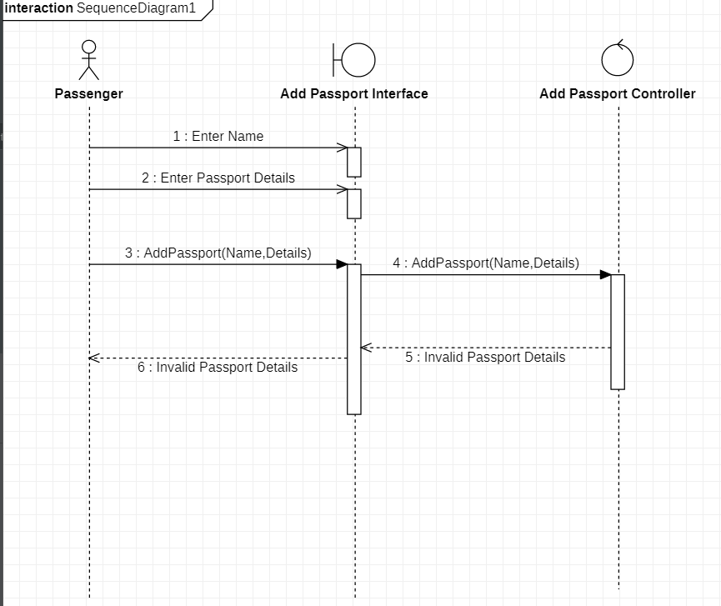

9 **MAINTAIN PASSENGER DETAILS**

Basic Flow

Ishaan Jain (2K18/SE/067) Dheeraj Rukwal (2K18/SE/055)

9.1 Add a Passenger

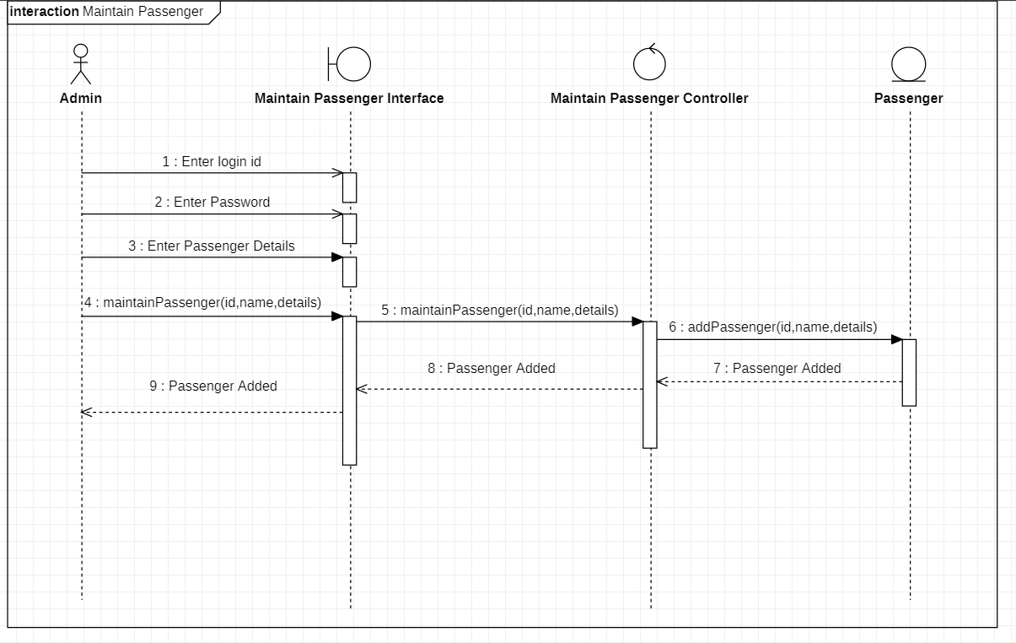

9.2 Update a Passenger

Ishaan Jain (2K18/SE/067) Dheeraj Rukwal (2K18/SE/055)

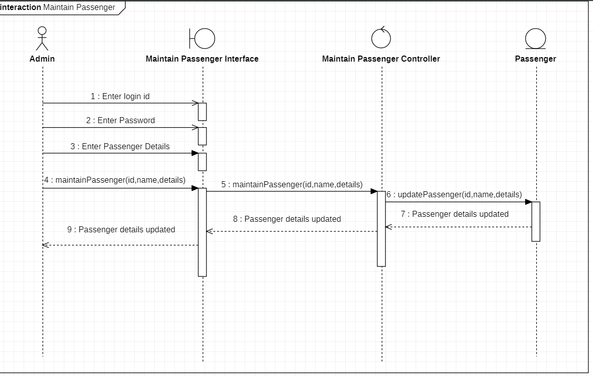

Ishaan Jain (2K18/SE/067) Dheeraj Rukwal (2K18/SE/055)

9.3 Delete a Passenger

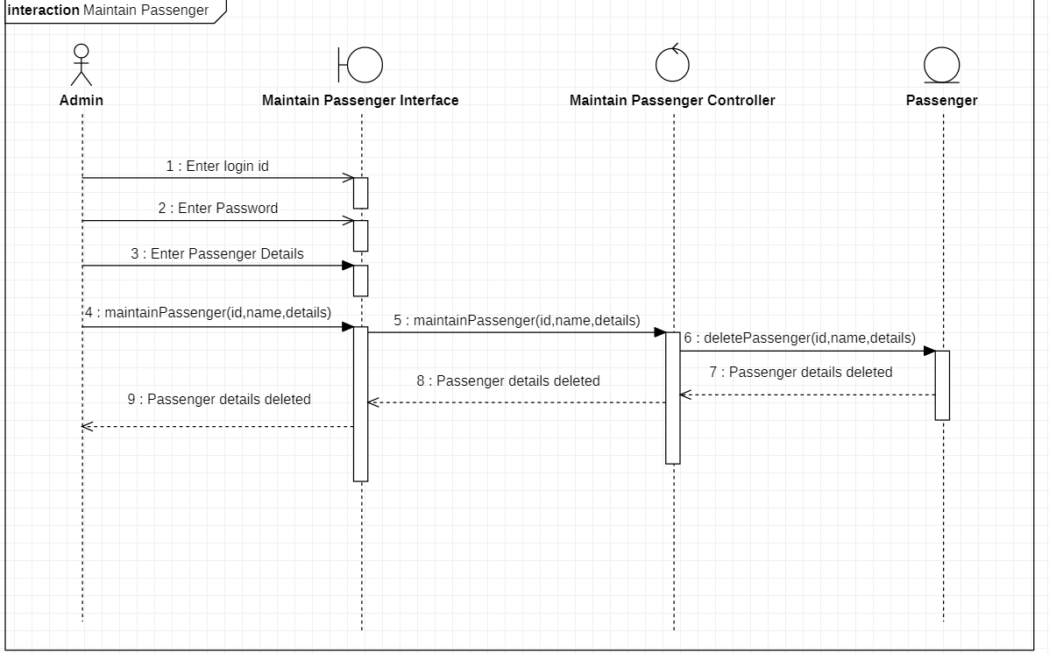

Alternate Flow

Ishaan Jain (2K18/SE/067) Dheeraj Rukwal (2K18/SE/055)

9.4 Invalid Details

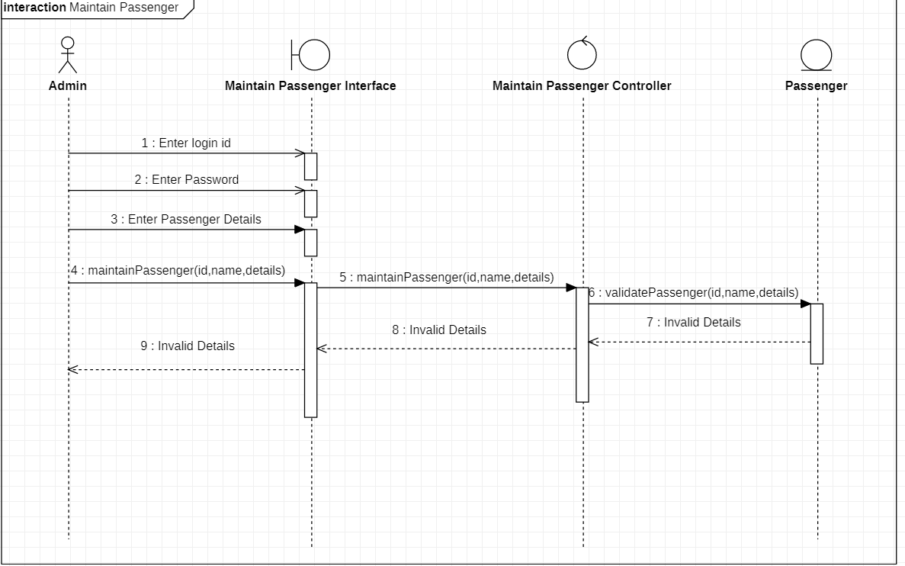

9.5 Passenger Already Exist- while adding passenger if the passenger already exist

Ishaan Jain (2K18/SE/067) Dheeraj Rukwal (2K18/SE/055)

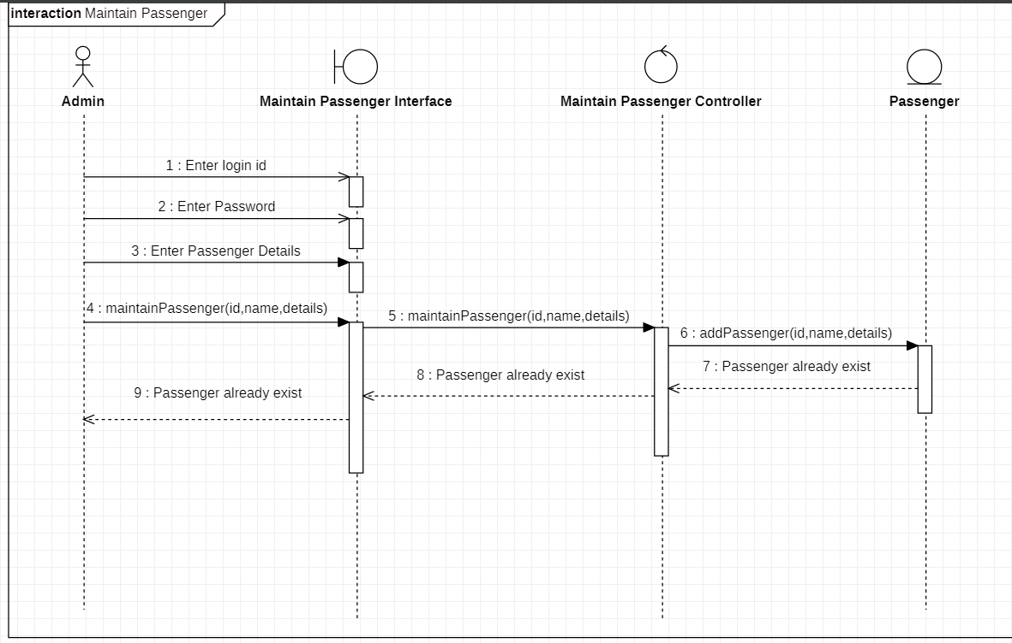

9.6 Passenger Not Found- if in the delete subflow passenger is not found

Ishaan Jain (2K18/SE/067) Dheeraj Rukwal (2K18/SE/055)

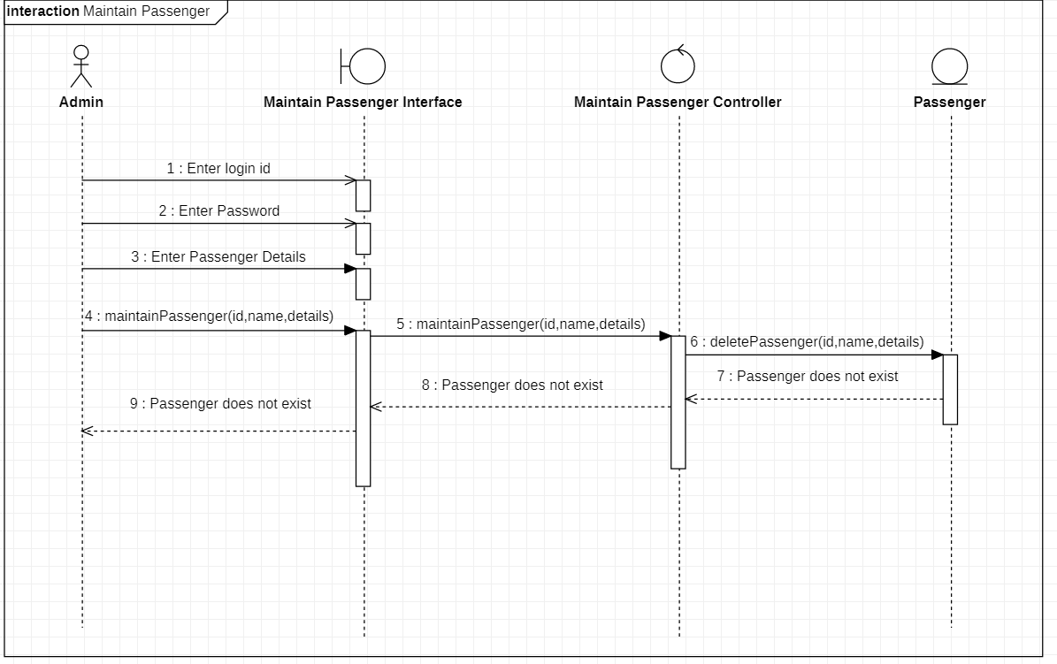

Ishaan Jain (2K18/SE/067) Dheeraj Rukwal (2K18/SE/055)

9.7 Update Cancelled

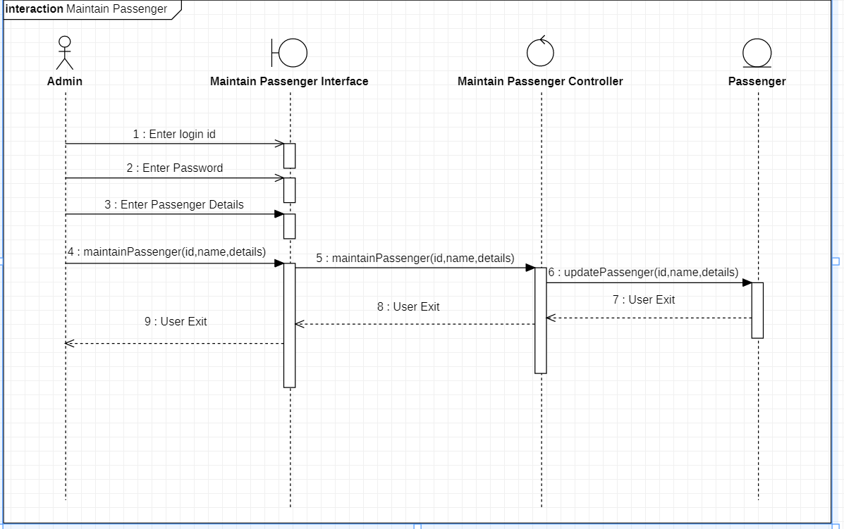

10. **MAINTAIN STAFF DETAILS**

Ishaan Jain (2K18/SE/067) Dheeraj Rukwal (2K18/SE/055)

BASIC FLOW

10.1 Add Staff

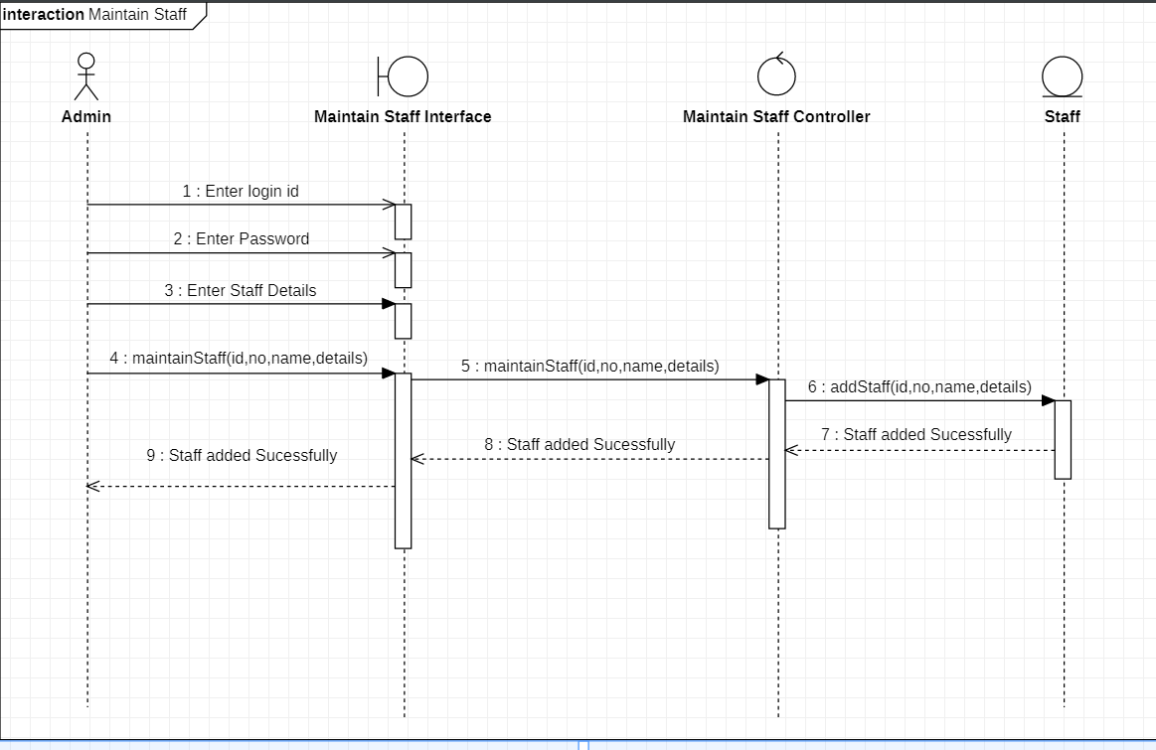

Ishaan Jain (2K18/SE/067) Dheeraj Rukwal (2K18/SE/055)

10.2 Update Staff

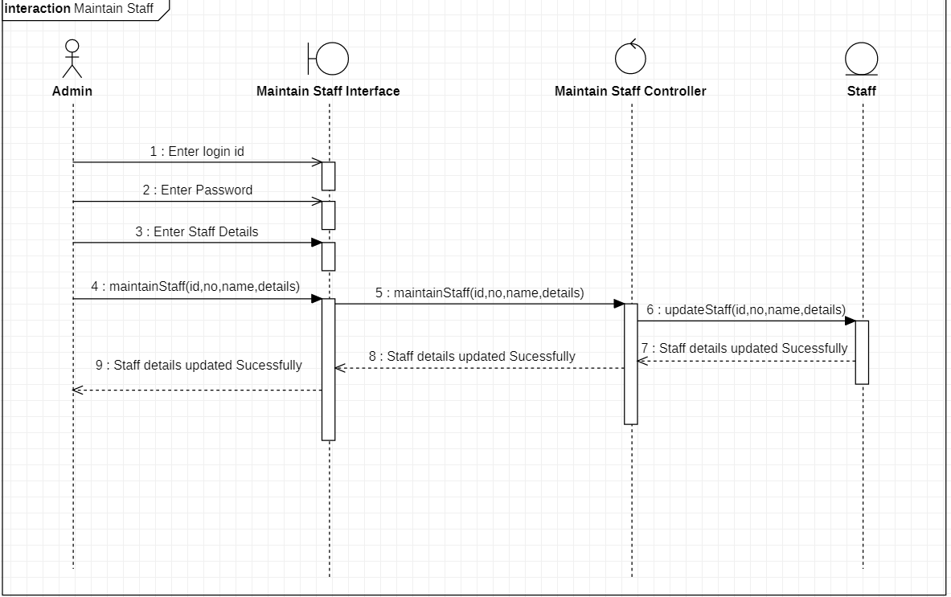

Ishaan Jain (2K18/SE/067) Dheeraj Rukwal (2K18/SE/055)

10.3 Delete Staff

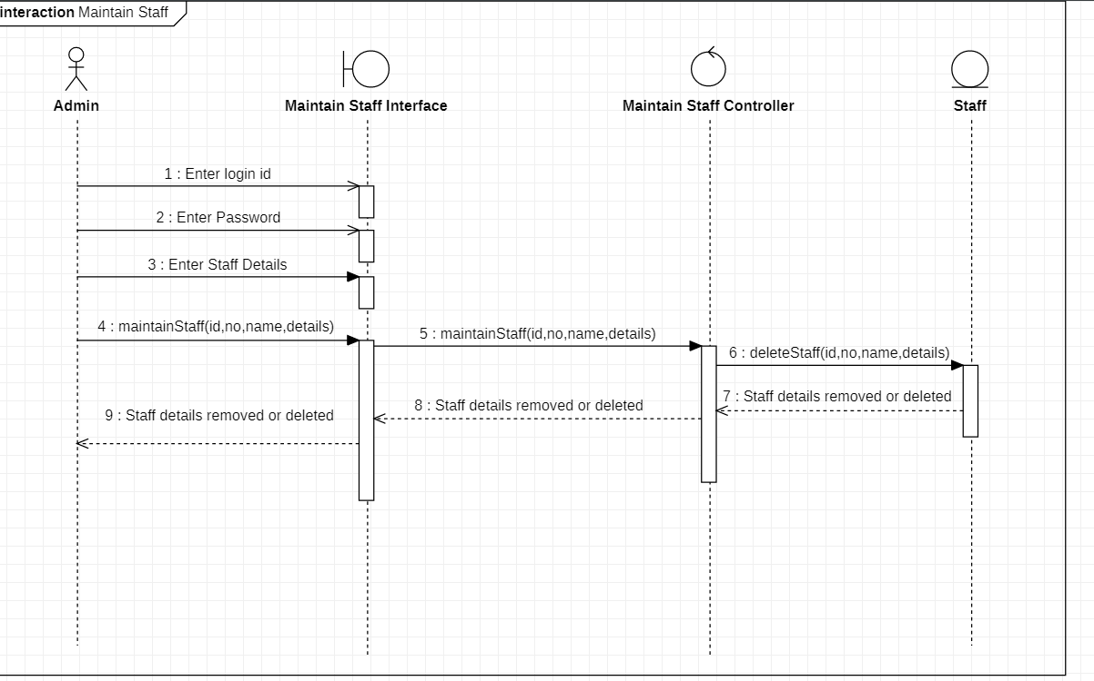

Ishaan Jain (2K18/SE/067) Dheeraj Rukwal (2K18/SE/055)

ALTERNATE FLOW

10.4 Invalid Details

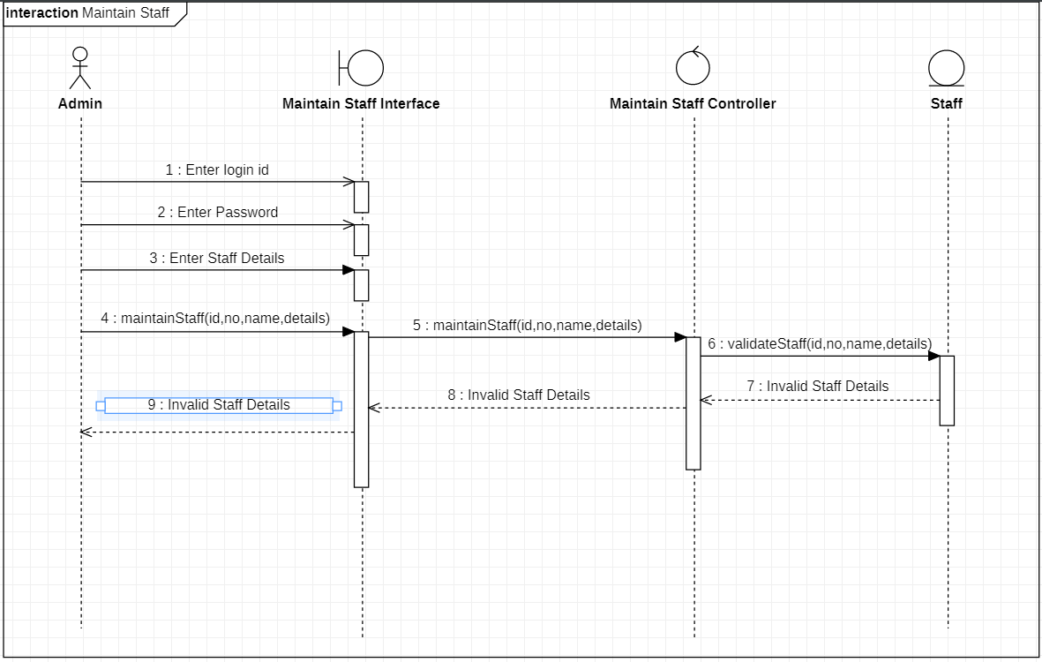

Ishaan Jain (2K18/SE/067) Dheeraj Rukwal (2K18/SE/055)

10.5 Staff Already Exist - in the add staff if the staff already exist

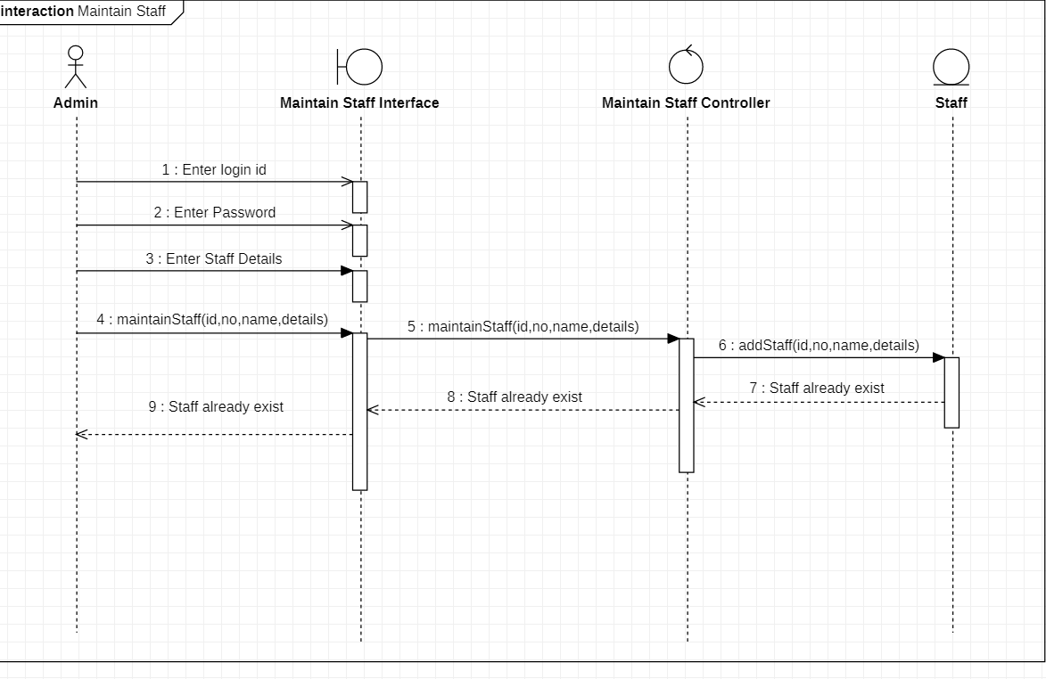

Ishaan Jain (2K18/SE/067) Dheeraj Rukwal (2K18/SE/055)

10.6 Staff Not found - in delete staff if the staff not found

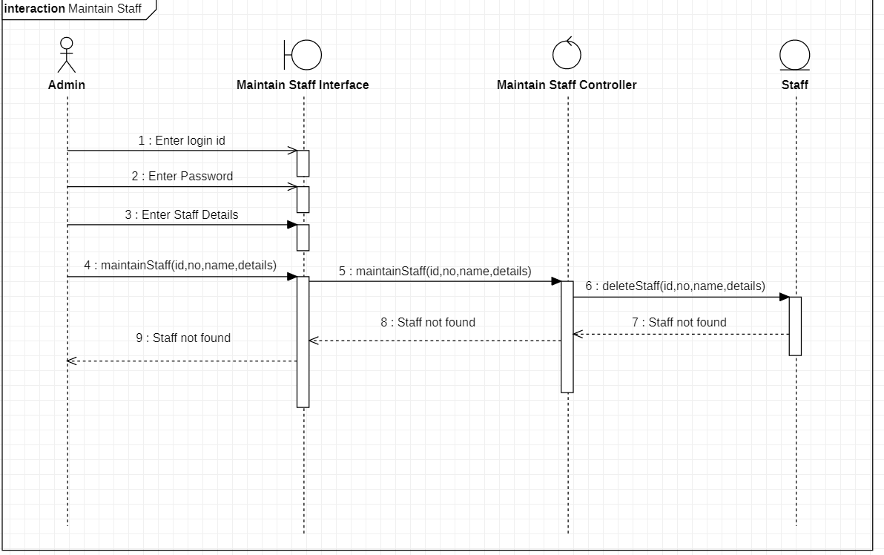

Ishaan Jain (2K18/SE/067) Dheeraj Rukwal (2K18/SE/055)

10.7 Update Cancelled

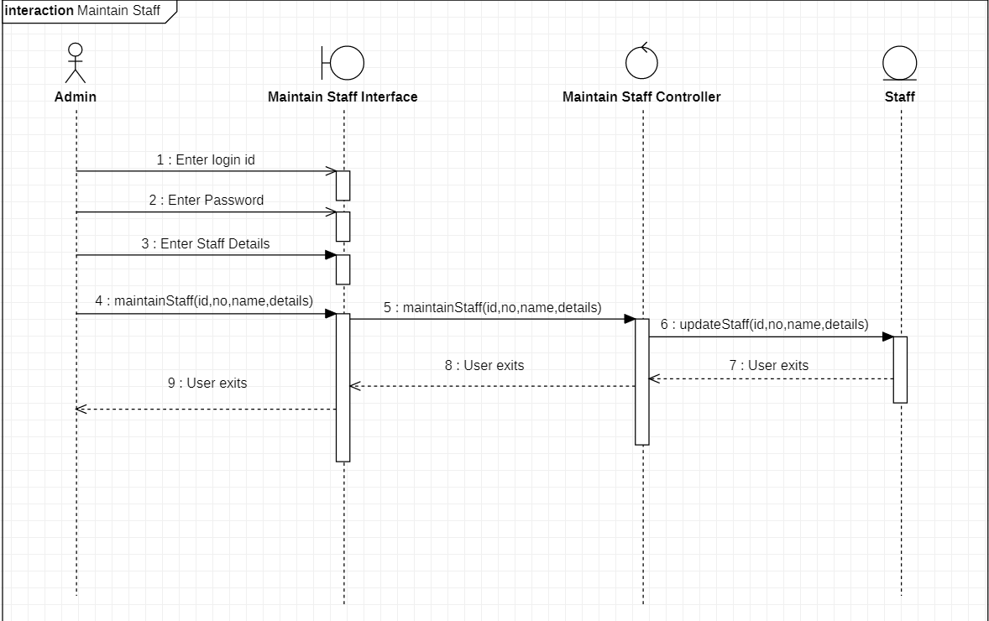

Ishaan Jain (2K18/SE/067) Dheeraj Rukwal (2K18/SE/055)

11 **MAINTAIN FLIGHT DETAILS**

Basic Flow

11.1 Add a Flight

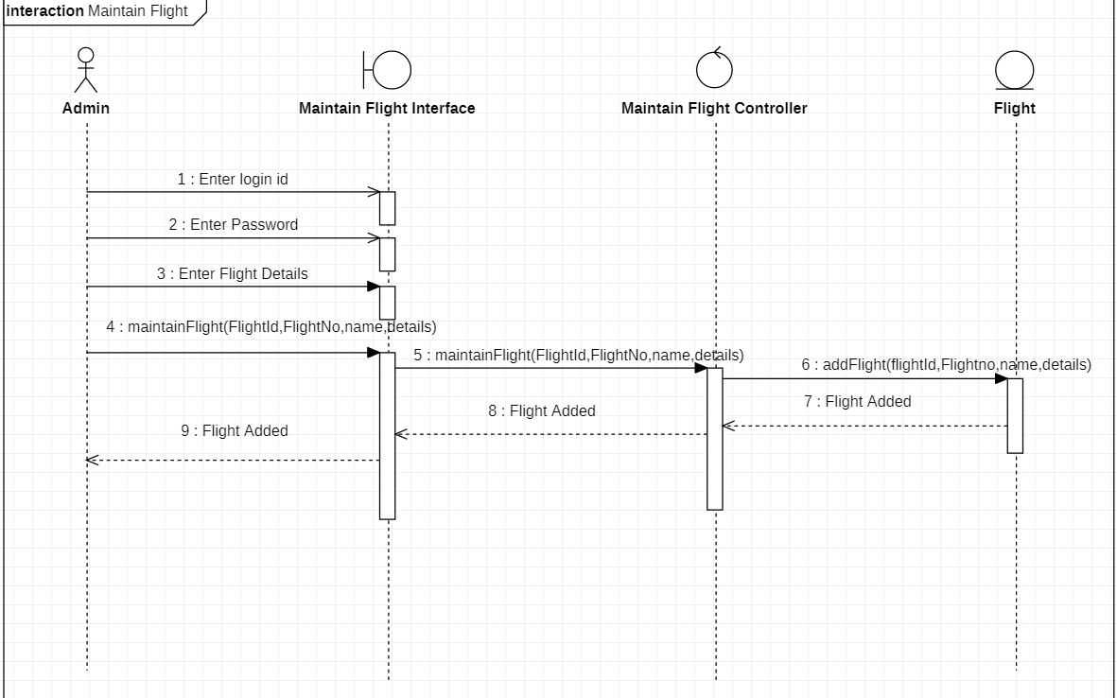

Ishaan Jain (2K18/SE/067) Dheeraj Rukwal (2K18/SE/055)

11.2 Update a Flight

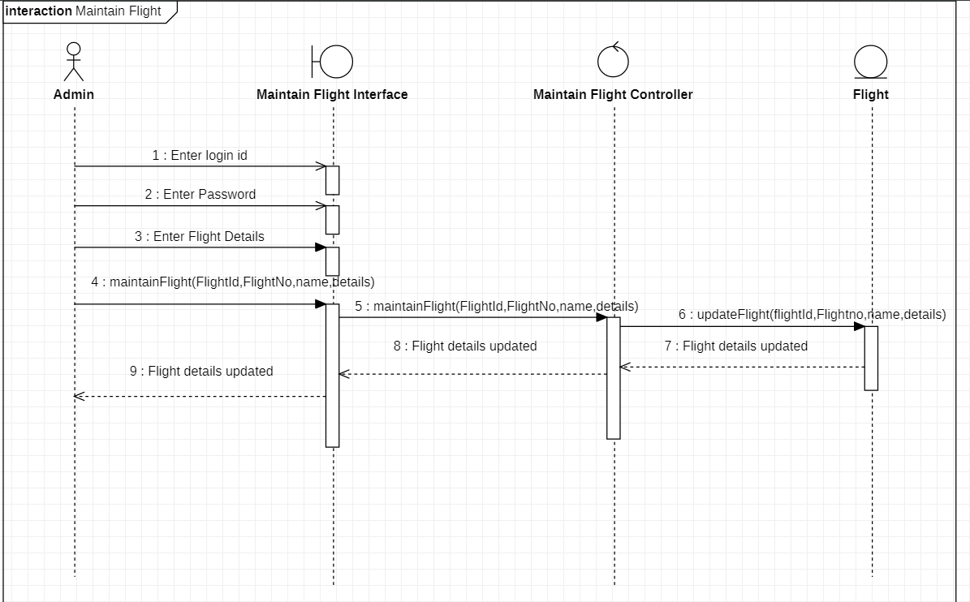

Ishaan Jain (2K18/SE/067) Dheeraj Rukwal (2K18/SE/055)

11.3 Delete Flight Details

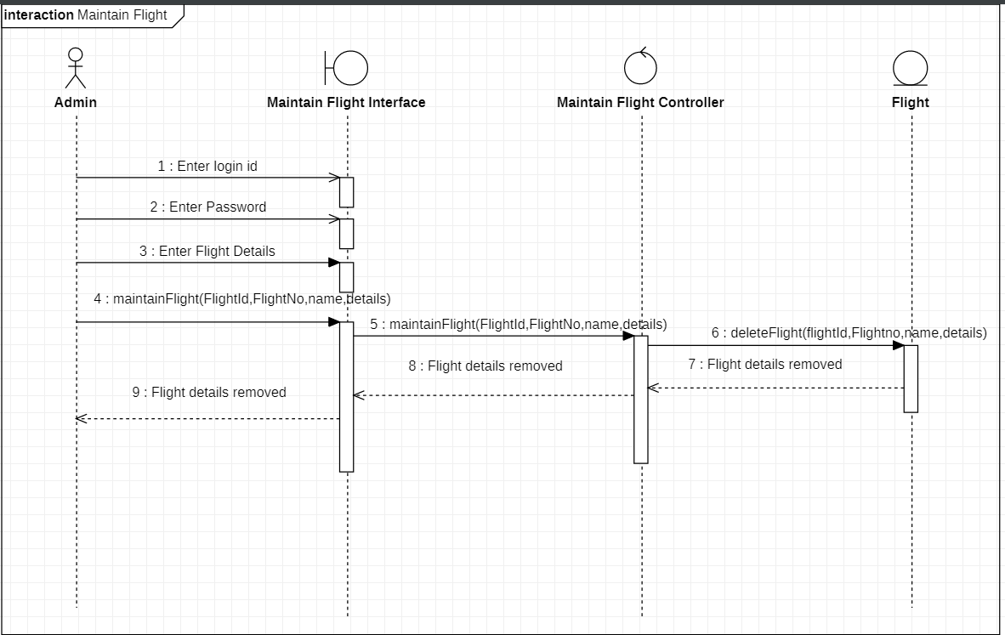

Ishaan Jain (2K18/SE/067) Dheeraj Rukwal (2K18/SE/055)

Alternate Flow

11.4 Invalid Flight Details

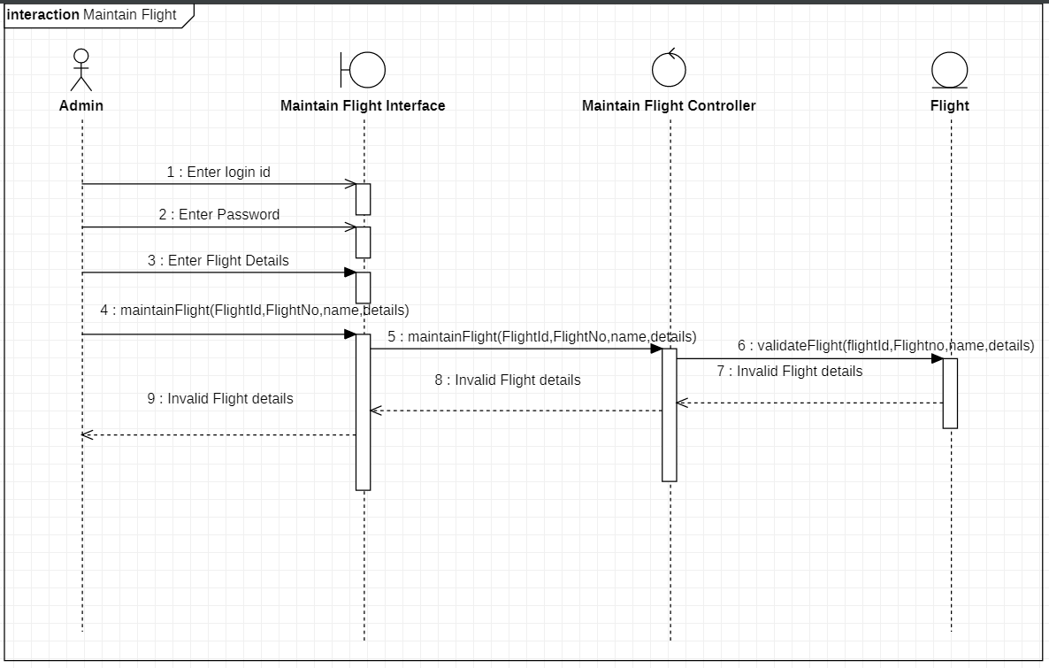

Ishaan Jain (2K18/SE/067) Dheeraj Rukwal (2K18/SE/055)

11.5 Flight Already Exist

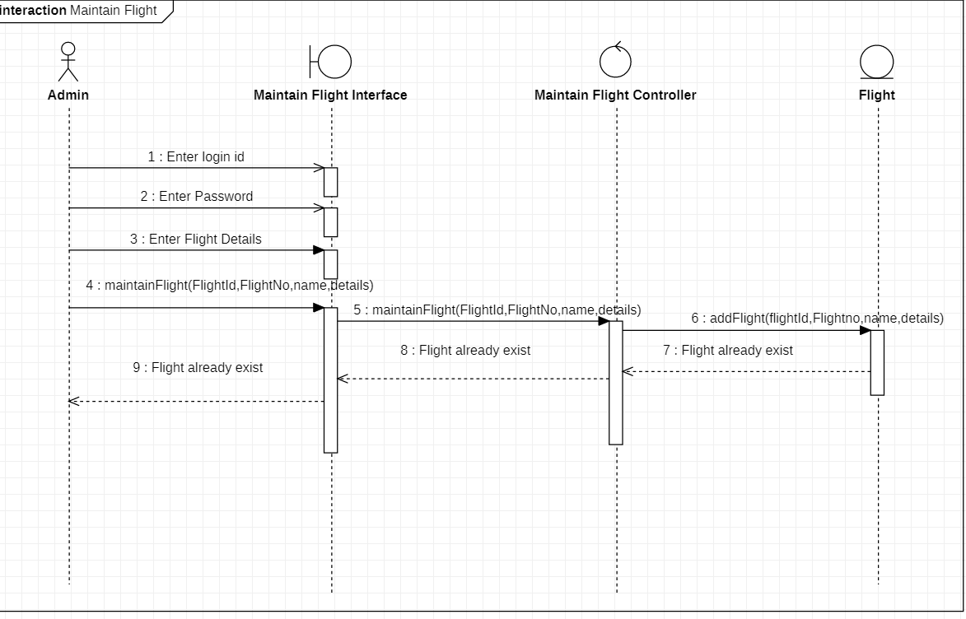

Ishaan Jain (2K18/SE/067) Dheeraj Rukwal (2K18/SE/055)

11.6 Update Cancelled

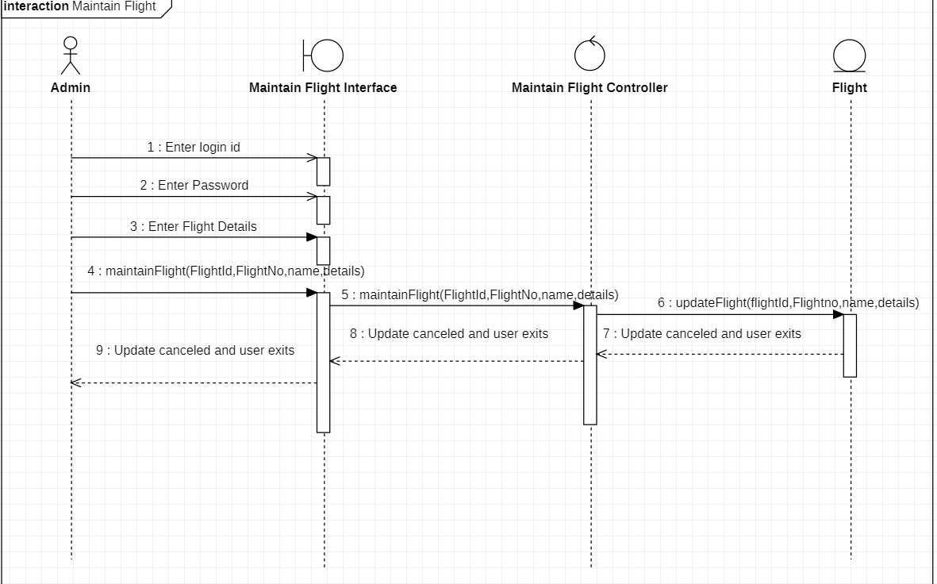

Ishaan Jain (2K18/SE/067) Dheeraj Rukwal (2K18/SE/055)

11.7 Flight Not Found

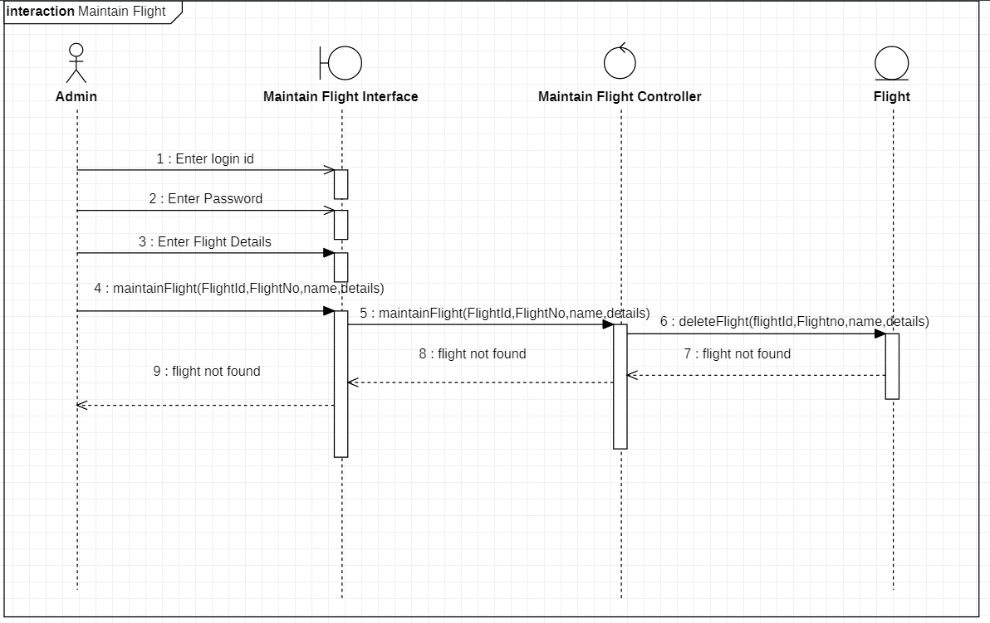

Ishaan Jain (2K18/SE/067) Dheeraj Rukwal (2K18/SE/055)

**ACTIVITY DIAGRAM**

1. Book Ticket Activity Diagram

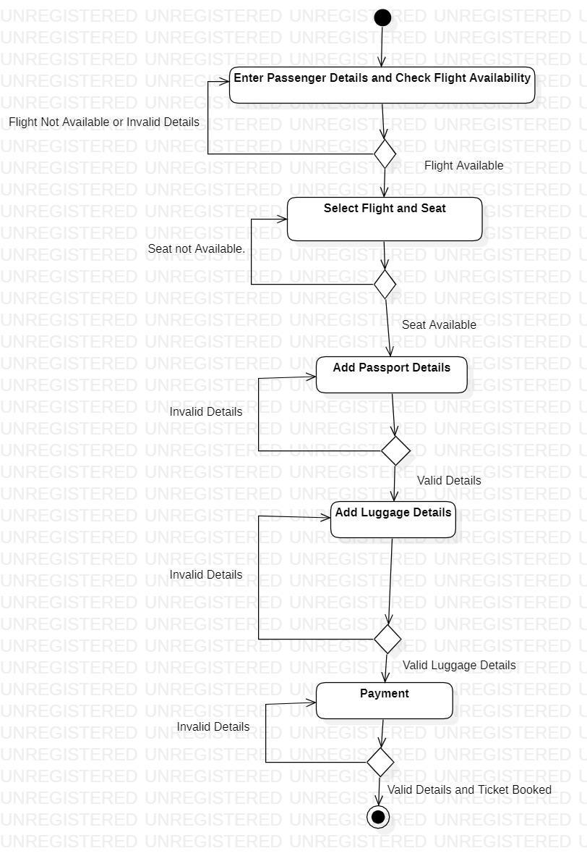

Ishaan Jain (2K18/SE/067) Dheeraj Rukwal (2K18/SE/055)

2.Register Activity Diagram

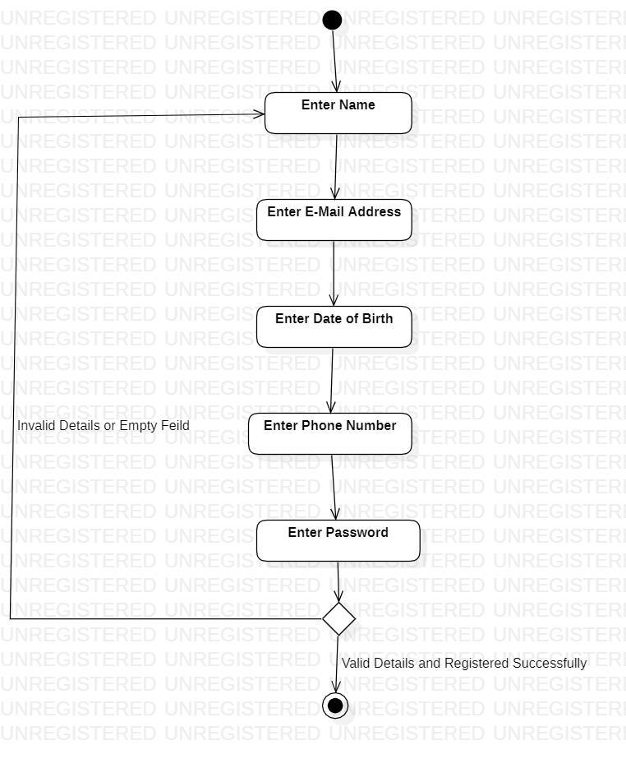

Ishaan Jain (2K18/SE/067) Dheeraj Rukwal (2K18/SE/055)

**STATE CHART DIAGRAM**

**Flight Entity**

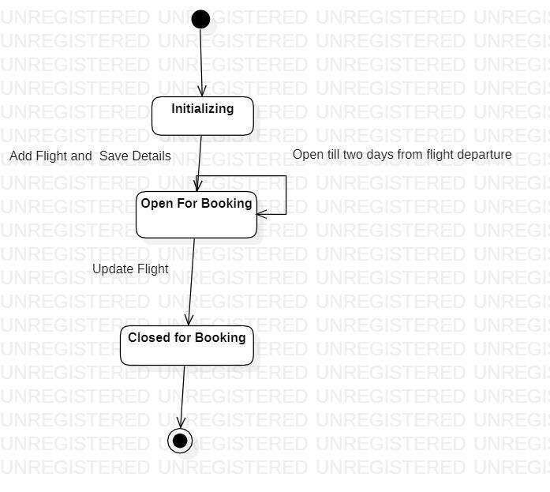

Ishaan Jain (2K18/SE/067) Dheeraj Rukwal (2K18/SE/055)

**TEST CASE MATRIX**

**Book Ticket :**

